**A PRPJECT REPORT ON**

**WWW.OCEAN.COM**

**An social media web site**

**PREPARED BY: SINDHIYA MAHESH K.**

**SHISHAGIYA KEVAL J.**

**PRINCIPAL:**

**Prof. Dipti N. Punjani**

**GUIDED BY:**

**Prof. Chirag s. Mehta**

**FOR FULFILLMENT OF BCA-V (2020-2021)**

**SUBMITTED TO: SAURASHTRA UNIVERSITY, RAJKOT.**

# NATIONAL COMPUTER COLLEGE

**4, OSWAL COLONY, SUNDARAM SOCIETY, SATYAM COLOTY ROAD, JAMNAGAR.**

**SINDHIYA MAHESH &SHISHAGIYA KEVAL WWW.OCEAN.COM**

**National Computer College**

1

**A PRPJECT REPORT ON**

**WWW.OCEAN.COM**

**An SOCIAL MEDIA WEBSITE**

**PREPARED BY: SINDHIYA MAHESH K.**

**SHISHAGIYA KEVAL J.**

**PRINCIPAL:**

**Prof. Dipti N. Punjani**

**GUIDED BY:**

**PROF. CHIRAG S. MEHTA**

**FOR FULFILLMENT OF BCA-V (2018-2019)**

**SUBMITTED TO: SAURASHTRA UNIVERSITY, RAJKOT.**

**NATIONAL COMPUTER COLLEGE**

**4, OSWAL COLONY, SUNDARAM SOCIETY, SATYAM COLOTY ROAD, JAMNAGAR.**

**SINDHIYA MAHESH &SHISHAGIYA KEVAL WWW.OCEAN.COM**

**National Computer College**

2

PREFACE

**This real life project is developed for submission of the course as a student of Bachelor of Computer Application. This Project deals with WWW.OCEAN.COM. So visit “**[**www.OCEAN.com**](http://www.OCEAN.com)**.”**

**With the help of this project, users can make there accounts and share their photos. In this Website Development we used MYSQL as back-End tool, which gives highest data security, which is necessary for the safe data security, which is necessary for the safe data secure to any system.**

**As the student of BCA, we have to undergo in project, where we often have opportunity as a students to develop an Application area.**

**It also includes a dissertation to be submitted by each of the BCA student as a part of the curriculum.**

**This project report is submitted as a part of the three years course of BCA-V conducted by Bachelor of Computer Application from Saurashtra University, Rajkot.**

**SINDHIYA MAHESH &SHISHAGIYA KEVAL WWW.OCEAN.COM**

**National Computer College**

3

ACKNOWLEDGEMENT

**We are the student of BCA-V, studying in the NATIONAL COPUTER COLLEGE, JAMNAGAR. Thanks to all**

**the people who has landed their support in shaping of the Information System.**

**We are thankful to PROF. PIYUSH D. PITRODA for giving us full guidance and co-operation in understanding the information system. We also thank them for their unconditional help in making of this project.**

**We have great deal of gratitude towards our Head of Department who encourage us in taking up this activity. We also thank our friends and family members for backing us and giving us the extra support that was very much needed.**

**Concluding, we thank that entire people who involved directly or indirectly in making of this project.**

SINDHIYA MAHESH K.

SHISHAGIYA KEVAL J.

**SINDHIYA MAHESH &SHISHAGIYA KEVAL WWW.OCEAN.COM**

**National Computer College**

4



**Oppo. 4-Oswal Colony, Sundaram Society, Satyam Colony Road, Jamnagar.**

**Phone no. (0288) 2711338**

GUIDE CERTIFICATE

**This is certify that the project report on school web site**

**“**[**www.OCEAN.com**](http://www.OCEAN.com)**.” submitted by SINDHIYA MAHESH K. & SHISHAGIYA KEVAL J. for the fulfilment of their work for the award of BCA-V degree to Saurashtra university, Rajkot has been completed under my supervision & guidance.**

**To the best of my knowledge, the matter presented has not been copied down from any other source. Also this report has not been submitted earlier for the award of any degree of diploma to Saurashtra University or any other university.**

**Date:**

**Place: Jamnagar**

**Prof. PIYUSH D. PITRODA**

**(Project Guide)**

**SINDHIYA MAHESH &SHISHAGIYA KEVAL WWW.OCEAN.COM**

**National Computer College**

6

**INDEX**

**Title Page No.**

About Saurashtra University 7

National Computer College 8

About Organization 9

Features of Project 10

SDLC 11

Software Used 12

About PHP 13

About Mysql 14

About Apache Web Server 15

DFD 16

Data Dictionary 17

Validations Used 18

Site Map 19

Snapshots 20

Coding 21

Bibliography 22

Conclusion 23

**SINDHIYA MAHESH &SHISHAGIYA KEVAL WWW.OCEAN.COM**

**National Computer College**

7

SAURASHTRA UNIVERSITY

**The Saurashtra University is one of the most well known universities.**

**It was established on 23rd may, 1968. It was fairly reputed university in India conducting various courses regarding the dream of 21st century. The university in going day by day, this provides the student the courses level from the graduate to PH.D.**

**Shree Haribhai Trivedi and Shree Dolarbhai Mankad print the title magazine in 1958 the resolution passed and 16 August, 1960. It was accepted in the 3rd five year plan of Gujarat, which is started in 1961-62. In 1965 December, the rules regarding university got the permission and 23 august, 1966 certain section is implemented by the result of Saurashtra University started.**

**The Saurashtra University works officially at 23 may, 1967. At the same time 35 colleges and 2 permitted institutions were started Rajkot, Bhavnagar, Amreli, Junaghdh, and Surendranagar districts. The total students were about 18000. Then in the same year two colleges are permitted and 37 colleges existed.**

**SINDHIYA MAHESH &SHISHAGIYA KEVAL WWW.OCEAN.COM**

**National Computer College**

8

NATIONAL COMPUTER COLLEGE

**Oppo. 4-Oswal Colony, Sundaram Society, Satyam Colony Road, Jamnagar.**

**Phone no. (0288) 2711338**

**National Computer College is begun in year 2000. It is affiliated with Saurashtra University.**

**Two courses are available in National Computer College. They are Bachelor of Computer College (B.C.A), Bachelor of Business Administration (B.B.A).**

**As and when we surrounded by difficulties and problems, faculties always guide us and solve our problems. Our principal PROF. DIPTI PUNJANI always inspired us to go ahead though in most difficult situations. The authority persons and all the staff members of National Computer College are good care taking and always helped us in any situation. Each and every subject is explained very easily and in detail so that student can understand very easily and in details so that students can understand very easily. The faculties associated with the college are very helpful & co-operative.**

**\*Staff of National Computer College\***

**Principal: Prof. Dipti Punjani**

**Faculties: Prof. Hasmukh Domadiya**

**Prof.Chirag Mehta Prof.Piyush Pitroda Prof.Rohit Pambhar**

**SINDHIYA MAHESH &SHISHAGIYA KEVAL WWW.OCEAN.COM**

**National Computer College**

10

**Features of Project**

* **The Features of project are described below:**
* **User can post there photos and share moments.**
* **User can message there friends to have conversion.**
* **User can see there friends posts and also like that and comment on posts.**
* **User can send friend request to other user .**
* **User has right to accept the request or reject friend requests.**
* **User can visit other users profile**

**SINDHIYA MAHESH &SHISHAGIYA KEVAL WWW.OCEAN.COM**

**National Computer College**

11

Software Development Life Cycle

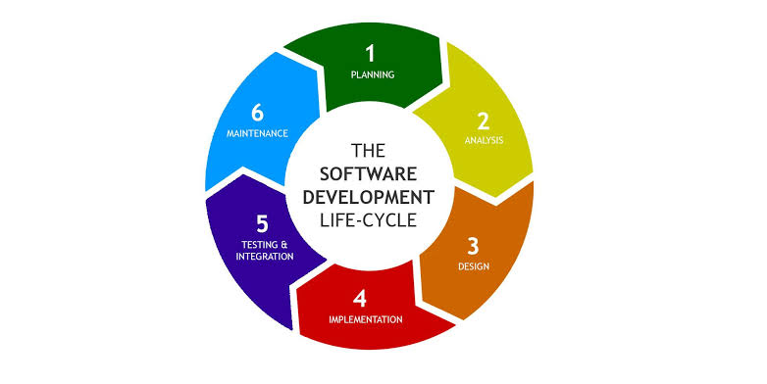

**SINDHIYA MAHESH &SHISHAGIYA KEVAL WWW.OCEAN.COM**

**National Computer College**

12

**Software Used**

* **Front End:**
* **PHP**
* **HTML**
* **Back End:**

 **MySQL**

**SINDHIYA MAHESH &SHISHAGIYA KEVAL WWW.OCEAN.COM**

**National Computer College**

13

About PHP

* + **Introduction to PHP**
* **The full form of PHP is “hypertext pre-processor”. Its original name was “personal home page”.**
* **Rasmus lerdorf software engineer, apache team member is the creator and original driving force behind PHP. The first part of PHP was developed for his personal use in late 1994.**
* **By the middle of 1997, PHP was being used on approximately 50,000 sites worldwide.**
* **PHP costs you nothing. It is open source language and doesn’t need to purchase it for development.**
* **PHP is server-side scripting language, which can be embedded in HTML or used as a stand-alone.**
* **PHP is an official module of Apache HTTP server.**
* **PHP is fully cross-platform, meaning it runs native on several flavours of UNIX, as well as on windows and now on Mac OS X.**
* **PHP is easy to learn, compared to the others. A lot of ready-made PHP scripts are freely available in market so, you can use them in your project or get some help from them.**

**SINDHIYA MAHESH &SHISHAGIYA KEVAL WWW.OCEAN.COM**

**National Computer College**

14

About MySQL

* **MySQL, the most popular open source SQL database management system, is developed, distributed, and supported by MySQL AB.**
* **MySQL AB is a commercial company, founded by the MySQL developers. It is a second generation open source company that unites open source values and methodology with a successful business model.**
* **The MySQL website (**[**http://www.mysql.com/**](http://www.mysql.com/)**) provides the latest information about MySQL software and MySQL AB.**
* **The official way to pronounce “MySQL” is “My ESS QueEll” (not “my sequel”), but we don’t mind if you pronounce it as “my sequel” or in some other localized way.**
* **MySQL is a relational database management system.**
* **The MySQL RDBMS is very fast, reliable, and easy to use.**

**SINDHIYA MAHESH &SHISHAGIYA KEVAL WWW.OCEAN.COM**

**National Computer College**

15

About Apache Web Server

* **Apache web server is an open source web server creation, deployment and management software. Initially developed by a group of software programmers, it is now maintained by the Apache Software Foundation.**
* **As of 2013, with over 100 millions websites and over 50 percent of the most commonly used applications for website hosting.**
* **So basically a web server is the software that receives your request to access a webpage. It runs a few security checks on your HTTP request and takes you to the web page. It then serves you the document you requested.**
* **A very long history of reliability and performance.**
* **Mass adoption means there is a lot of documentation out there and it is very easy to get help with trouble, you might run on it.**
* **It is one of the most feature rich web servers available.**

DataFlowDiagram

**0 Level Diagram :-**

**SOCIAL MEDIA WEBSITE**

**ADMIN**

INFORMATION

ADMIN PENEL

**USER**

USER LOGIN

SEE POSTS

**1st Level Diagram :-**

**USER**

**ADMIN**

1.0 SIGN-IN &LOG-IN

2.0 PROFILE REGISTRATION

3.0 POST SOMTHING

CHECKUP DETAIL

USER UNFO.

5.0 NEWS FEED

USER DETAIL

USER DETAIL

4.0 USER DETAIL



**2ND Level Diagram :-**

**USER**

1.0 SIGN-IN &LOG-IN

CHECKUP DETAIL

USER NAME

USER VISIT

2.0 PROFILE REGISTRATION

3.0 POST SOMTHING

NEWS FEED GANRETED

4.0 USER DETAIL

REQUEST TO

RESPONCE

REQUEST TO

RESPONCE

NEWS FEED

FRIENDS POSETS

Data Structure

**Admin**

|  |  |  |
| --- | --- | --- |
| Name | Data type | Key attribute |
| |  | | --- | | id | | int(11) | Primary key |
| |  |  | | --- | --- | | adminname |  | | varchar(100) | - |
| |  | | --- | | password | | varchar(100) | - |
|  |  |  |

**Comment**

|  |  |  |
| --- | --- | --- |
| Name | Data type | Key attribute |
| |  | | --- | | id | | int(11) | Primary key |
| |  |  | | --- | --- | | post_body |  | | text | - |
| |  |  | | --- | --- | | posted_by |  | | varchar(100) | - |
| |  |  | | --- | --- | | posted_to |  | | varchar(100) | - |
| |  |  | | --- | --- | | date_added |  | | |  | | --- | | datetime | | - |
| |  | | --- | | post_id | | |  | | --- | | int(11) | | - |
|  |  |  |

**Friend_request**

|  |  |  |
| --- | --- | --- |
| Name | Data type | Key attribute |
| |  | | --- | | id | | int(11) | Primary key |
| |  |  | | --- | --- | | user_to |  | | varchar(100) | - |
| |  |  | | --- | --- | | user_from |  | | varchar(100) | - |
|  |  |  |

**Like**

|  |  |  |
| --- | --- | --- |
| Name | Data type | Key attribute |
| |  | | --- | | id | | int(11) | Primary key |
| |  |  | | --- | --- | | username |  | | varchar(100) | - |
| |  |  | | --- | --- | | Post_id |  | | varchar(100) | - |
|  |  |  |

**Message**

|  |  |  |
| --- | --- | --- |
| Name | Data type | Key attribute |
| |  | | --- | | id | | int(11) | Primary key |
| |  |  | | --- | --- | | msg_body |  | | Text | - |
| |  |  | | --- | --- | | user_from |  | | varchar(100) | - |
| |  |  | | --- | --- | | user_to |  | | varchar(100) | - |
| |  |  | | --- | --- | | date_added |  | | |  | | --- | | datetime | | - |
|  |  |  |

**Post**

|  |  |  |
| --- | --- | --- |
| Name | Data type | Key attribute |
| |  | | --- | | id | | int(11) | Primary key |
| |  |  | | --- | --- | | post_body |  | | text | - |
| |  |  | | --- | --- | | posted_by |  | | varchar(100) | - |
| |  |  | | --- | --- | | images |  | | varchar(100) | - |
| |  |  | | --- | --- | | date_added |  | | |  | | --- | | datetime | | - |
| |  | | --- | | likes | | |  | | --- | | int(11) | | - |
|  |  |  |

**User**

|  |  |  |
| --- | --- | --- |
| Name | Data type | Key attribute |
| |  | | --- | | id | | int(11) | Primary key |
| |  |  | | --- | --- | | frist_name |  | | varchar(100) | - |
| |  |  | | --- | --- | | fast_name |  | | varchar(100) | - |
| |  |  | | --- | --- | | date_added |  | | |  | | --- | | datetime | | - |
| |  | | --- | | fsername | | |  | | --- | | varchar(50) | | - |
| email | varchar(100) | - |
| dob | date | - |
| gender | varchar(10) | - |
| password | varchar(50) | - |
| profile_pic | varchar(100) | - |
| cover_pic | varchar(100) | - |
| num_post | int(4) | - |
| num_likes | int(4) | - |
| friend_array | text | - |
|  |  |  |

Menu structure/site map

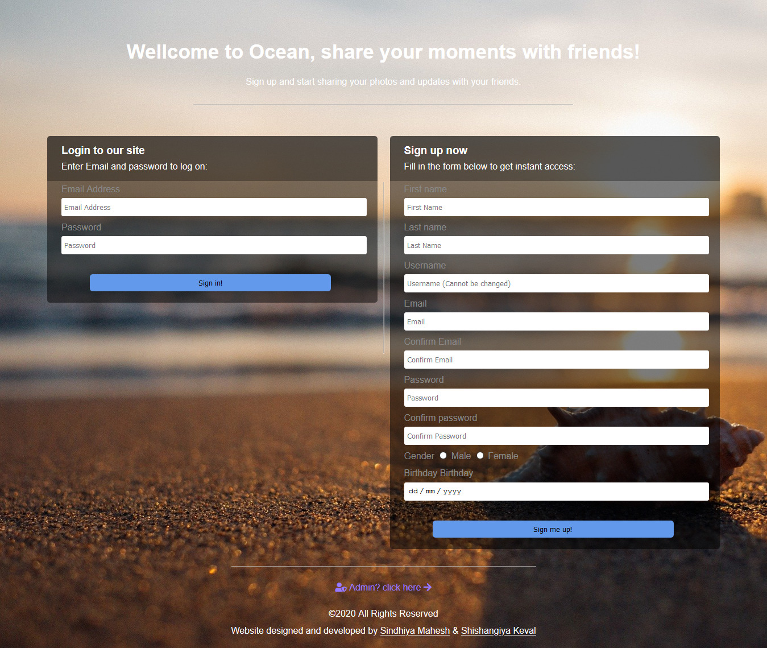

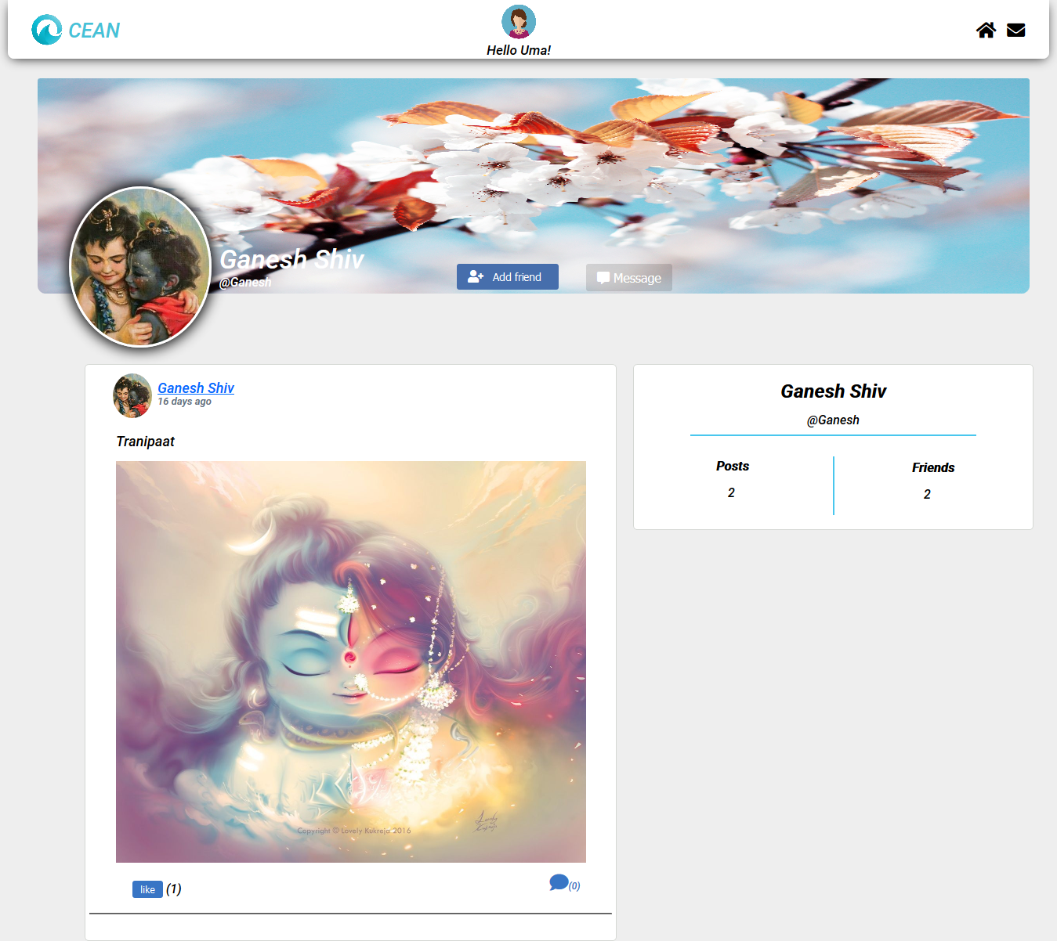

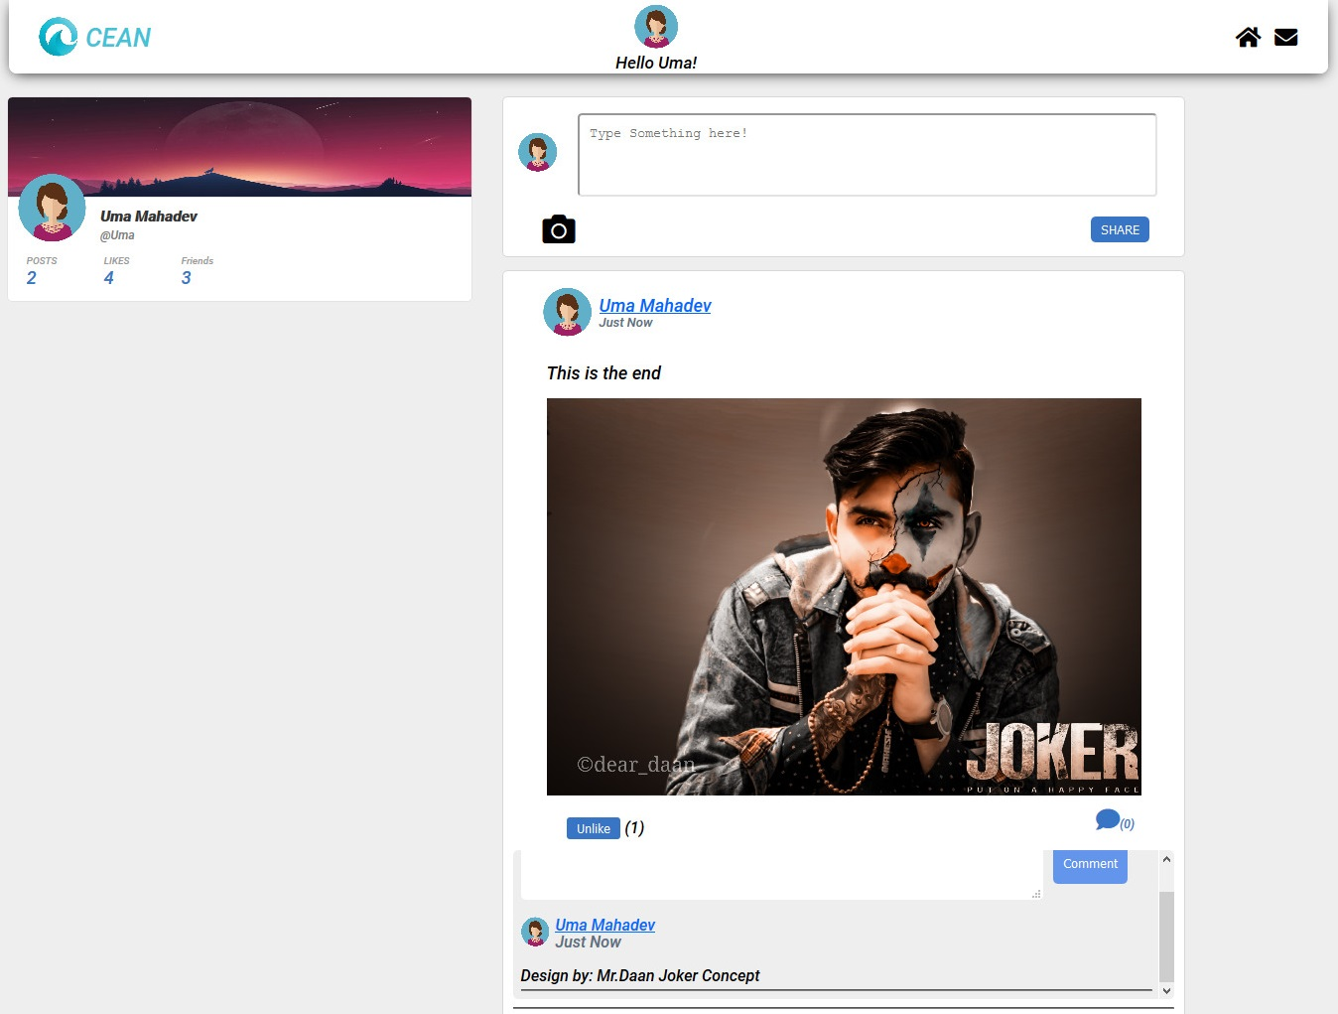

ADMIN PENEL :-

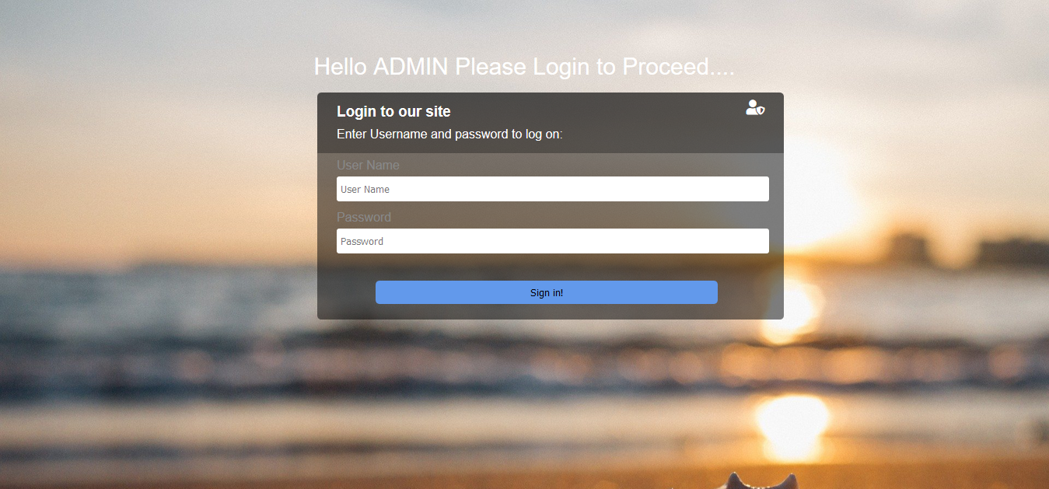

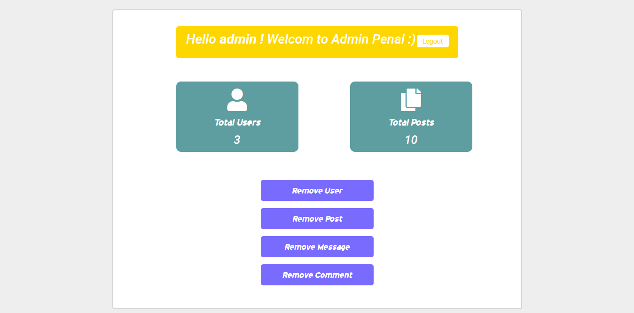

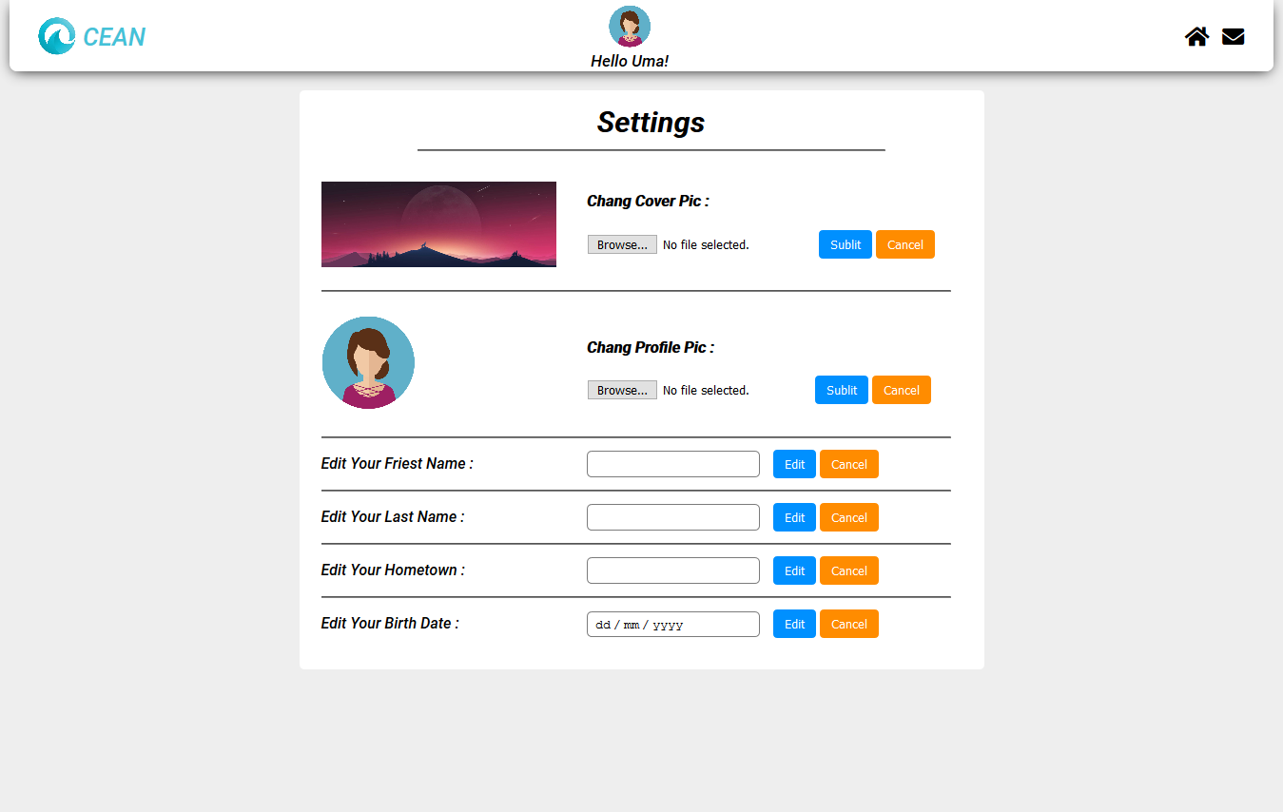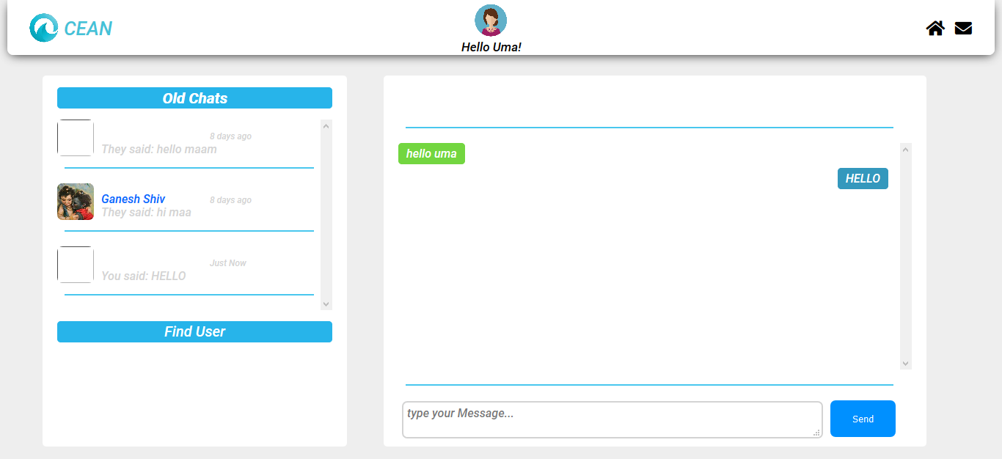

Codding

# Account_setting.php

<?php include 'database/header.php';   
 include 'database/classes/User.php';  
 include 'database/classes/Post.php';  
 $msg = "";  
  
 $user_detail_query = mysqli_query($con,"select * from users where username='$userLoggedIn'");  
 $user_array = mysqli_fetch_array($user_detail_query);  
  
 if(isset($_POST['submit_cover_pic'])){  
 $uploadOk = 1;  
 $imageName = $_FILES['cover_pic']['name'];  
 $errorMessage = "";  
   
 if($imageName != ""){  
 $targetDir = "assets/images/cover_pics/";  
 $imageName = $targetDir . basename($imageName);  
 $imageFileType = pathinfo($imageName, PATHINFO_EXTENSION);  
   
 if($uploadOk){  
 if(move_uploaded_file($_FILES['cover_pic']['tmp_name'], $imageName)){  
 //image Upload Okey  
 $errorMessage = "uploaded";  
 }  
 else{  
 $uploadOk = 0;  
 $errorMessage = "fail to upload";  
 }  
 }  
 }  
   
 if($uploadOk){  
 $update_covet_pic = mysqli_query($con, "update users set cover_pic='$imageName' where username='$userLoggedIn'") or die(mysqli_error($con));  
 // header("Location: account_settings.php");  
 }  
 else{  
 echo $errorMessage;  
 }  
  
  
 }  
  
 if(isset($_POST['submit_profile_pic'])){  
 $uploadOk = 1;  
 $imageName = $_FILES['profile_pic']['name'];  
 $errorMessage = "";  
   
 if($imageName != ""){  
 $targetDir = "assets/images/profile_pics/";  
 $imageName = $targetDir . basename($imageName);  
 $imageFileType = pathinfo($imageName, PATHINFO_EXTENSION);  
   
 if($uploadOk){  
 if(move_uploaded_file($_FILES['profile_pic']['tmp_name'], $imageName)){  
 //image Upload Okey  
 $errorMessage = "uploaded";  
 }  
 else{  
 $uploadOk = 0;  
 $errorMessage = "fail to upload";  
 }  
 }  
 }  
   
 if($uploadOk){  
 $update_covet_pic = mysqli_query($con, "update users set profile_pic='$imageName' where username='$userLoggedIn'") or die(mysqli_error($con));  
 // header("Location: account_settings.php");  
 }  
 else{  
 echo $errorMessage;  
 }  
  
  
 }  
  
 $Fname = "";  
 $Lname = "";  
 $DOB = "";  
 $h_town = "";  
   
 $error_array = array();  
  
 if(isset($_POST['submit_Fname'])){  
 $Fname = $_POST['Fname'];  
 $Fname = strip_tags($Fname); //remove thigs like <,>...etc tages  
 $Fname = mysqli_real_escape_string($con, $Fname); //egnore the ' in post boddy  
 $query = mysqli_query($con, "update users set first_name='$Fname' where username='$userLoggedIn'") or die("cannot update".mysqli_error($con));  
 if($query)  
 array_push($error_array, "First name Updated :)");   
 else   
 array_push($error_array, "Fail to Updated First name :(");  
 // header("Location: account_settings.php");  
 }  
  
 if(isset($_POST['submit_Lname'])){  
 $Lname = $_POST['Lname'];  
 $Lname = strip_tags($Lname); //remove thigs like <,>...etc tages  
 $Lname = mysqli_real_escape_string($con, $Lname); //egnore the ' in post boddy  
 $query = mysqli_query($con, "update users set last_name='$Lname' where username='$userLoggedIn'") or die("cannot update".mysqli_error($con));  
 if($query)  
 array_push($error_array, "last name Updated :)");   
 else   
 array_push($error_array, "Fail to Updated last name :(");  
 // header("Location: account_settings.php");  
 }  
  
 if(isset($_POST['submit_date'])){  
 $DOB = $_POST['DOB'];  
 $DOB = strip_tags($DOB); //remove thigs like <,>...etc tages  
 $DOB = mysqli_real_escape_string($con, $DOB); //egnore the ' in post boddy  
 $query = mysqli_query($con, "update users set dob='$DOB' where username='$userLoggedIn'") or die("cannot update".mysqli_error($con));  
 if($query)  
 array_push($error_array, "Birth Date Updated :)");   
 else   
 array_push($error_array, "Fail to Updated Birth Date :(");   
 // header("Location: account_settings.php");  
 }  
  
 if(isset($_POST['submit_htown'])){  
 $h_town = $_POST['h_town'];  
 $h_town = strip_tags($h_town); //remove thigs like <,>...etc tages  
 $h_town = mysqli_real_escape_string($con, $h_town); //egnore the ' in post boddy  
 $query = mysqli_query($con, "update users set hometown='$h_town' where username='$userLoggedIn'") or die("cannot update".mysqli_error($con));  
 if($query)  
 array_push($error_array, "Hometown Updated :)");   
 else   
 array_push($error_array, "Fail to Updated Hometown :(");   
 // header("Location: account_settings.php");  
 }  
  
?>  
  
<style>  
 .setting_main{  
 width: 700px;  
 height: auto;  
 background: white;  
 margin-top: 95px;  
 margin-bottom: 150px;  
 margin-left: auto;  
 margin-right: auto;  
 border-radius: 5px;  
 padding-top: 25px;  
 padding-bottom: 30px;  
 padding-left: 20px;  
 }  
 img{  
 height: 90%;  
 width: 90%;  
 }  
  
 .imgs{  
 height: 100px;  
 width: 40%;  
 }  
  
 .setting_span{  
 margin-left: 116px;  
 position: absolute;  
 }  
  
 hr{  
 width: 97%;  
 margin-left: 0px;  
 }  
  
 center{  
 font-size: 30px;  
 margin-bottom: 20px;  
 }  
  
 input[type="text"]{  
 margin-right: 10px;  
 padding: 5px;  
 border: 1px solid #7b7b7b;  
 background: #ffffff;  
 border-radius: 5px;  
 width: 170px;  
 }  
  
 input[type="submit"]{  
 padding: 5px 12px 5px 12px;  
 height: 30px;  
 background: #0090ff;  
 color: white;  
 border: none;  
 border-radius: 4px;  
 margin-top: auto;  
 margin-bottom: auto;  
 }  
  
 input[type="date"]{  
 width: 170px;  
 border-radius: 5px;  
 margin-right: 10px;  
 padding: 5px;  
 height: 15px;  
 border: 1px solid #7b7b7b;  
 }  
   
</style>  
  
 <div class="setting_main">  
 <center><b> Settings </b></center> <hr style="margin-left: auto; width: 70%; margin-bottom: 20px;">  
 <div class="main_wreper">  
 <div >  
 <table>  
 <form action="account_settings.php" method="post" enctype="multipart/form-data">  
 <tr class="r1">  
 <td class="imgs"> <img src='<?php echo $user_array['cover_pic']; ?>' height="50px"> </td>  
 <td class="covet_img"> <span><h4>Chang Cover Pic :<h4> <input type="file" name="cover_pic" id="cover"> <input type="submit" name="submit_cover_pic" value="Sublit"> <input type="submit" style="background: darkorange;" value="Cancel"></span> </td>  
 </tr>  
 <tr><td><hr style="width: 240%;"></td></tr>  
 <tr class="r2">  
 <td class="imgs2" > <img src='<?php echo $user_array['profile_pic']; ?>' style="height: 100px; width: 100px;"> </td>  
 <td > <span style="margin-top: 0px; margin-left: 182px;"> <h4>Chang Profile Pic :<h4> <input type="file" name="profile_pic" id="profile"><input type="submit" name="submit_profile_pic" value="Sublit"> <input type="submit" style="background: darkorange;" value="Cancel"></span> </td>  
 </tr>  
 <tr><td><hr style="width: 240%;"></td></tr>  
 <tr class="r4">  
 <td> <span> Edit Your Friest Name : </span> </td>  
 <td> <input type="text" name="Fname" id="Fname"> <input type="submit" name="submit_Fname" value="Edit"> <input type="submit" style="background: darkorange;" value="Cancel"> <?php if (in_array("Fail to update First name" , $error_array)) echo "<br>Fail to update First name"; elseif (in_array("First name Updated :)" , $error_array)) { echo "<br>First name update :)"; }   
 ?> </td>  
 </tr>  
 <tr><td><hr style="width: 240%;"></td></tr>  
 <tr class="r5">  
 <td> <span> Edit Your Last Name : </span> </td>  
 <td> <input type="text" name="Lname" id="Lname"> <input type="submit" name="submit_Lname" value="Edit"> <input type="submit" style="background: darkorange;" value="Cancel"> <?php if (in_array("Fail to update last Name" , $error_array)) echo "<br>Fail to update last Name"; elseif (in_array("Last name Updated :)" , $error_array)) { echo "<br>Last name Updated :)"; } ?> </td>  
 </tr>  
 <tr><td><hr style="width: 240%;"></td></tr>  
 <tr class="r6">  
 <td> <span> Edit Your Hometown : </span> </td>  
 <td> <input type="text" name="h_town" id="h_town"> <input type="submit" name="submit_htown" value="Edit"> <input type="submit" style="background: darkorange;" value="Cancel"> <?php if (in_array("Fail to update Hometown" , $error_array)) echo "<br>Fail to update Hometown"; elseif (in_array("Hometown Updated :)" , $error_array)) { echo "<br>Hometown Updated :)"; } ?> </td>  
 </tr>  
 <tr><td><hr style="width: 240%;"></td></tr>  
 <tr class="r7">  
 <td> <span> Edit Your Birth Date : </span> </td>  
 <td> <input type="date" name="DOB" id="DOB"> <input type="submit" name="submit_date" value="Edit"> <input type="submit" style="background: darkorange;" value="Cancel"> <?php if (in_array("Fail to update Birth date" , $error_array)) echo "<br>Fail to update Birth date"; elseif (in_array("Birth Date Updated :)" , $error_array)) { echo "<br>Birth Date Updated :)"; } ?> </td>  
 </tr>  
 </form>  
 </table>  
 </div>  
 </div>   
 </div>

Admin.php

<?php  
  
 include 'session-file.php';  
  
 $error_array = array();  
  
 if(isset($_POST['login_btn'])){  
 $Username = filter_var($_POST['log_user'], FILTER_SANITIZE_EMAIL);  
   
 $_SESSION['log_user'] = $Username;  
 $password = $_POST['log_password'];  
   
 $check_database_query = mysqli_query($con, "SELECT * FROM admin WHERE adminname='$Username' AND password='$password'")or die(mysqli_error($con));  
 $check_login_query = mysqli_num_rows($check_database_query);  
   
 if($check_login_query == 1){  
 $row = mysqli_fetch_array($check_database_query) or die(mysqli_error($con));  
 $username = $row['adminname'];  
   
 $user_closed_query = mysqli_query($con,"select * from admin where adminname='$Username' and user_closed='yes'");   
 $_SESSION['username'] = $username;  
 header("Location: admin_home.php");  
 exit();  
 }  
 else{  
 array_push($error_array, "Username or Password was incorrect");  
 }  
 }  
?>  
<!DOCTYPE html>  
<html lang="en">  
<head>  
 <meta charset="UTF-8">  
 <meta name="viewport" content="width=device-width, initial-scale=1.0">  
 <link rel="stylesheet" href="assets/register.css">  
 <link rel="stylesheet" href="assets/fontawesome-free-5.15.1-web/css/all.css">  
 <link rel="shortcut icon" href="images/favigon.jpg" type="image/x-icon">  
 <title>Welcome Admin</title>  
  
 <style>  
 .from_wreper{  
 margin-left: 325px;  
 margin-right: auto;  
 }  
 .upper_body{  
 color: white;  
 font-size: 30px;  
 text-align: center;  
 margin-top: 70px;  
 margin-bottom: 10px;  
 }  
   
 </style>  
  
</head>  
<body>  
 <div class="upper_body">  
 Hello ADMIN Please Login to Proceed....  
 </div>  
 <div class="from_wreper">  
 <div class="signin-form">  
 <div class="form-top-left">  
 <h3 style="padding-top:10px;">Login to our site <i class="fas fa-user-shield" style="float: right;"></i></h3>  
 <p style="margin-top:-20px; padding-bottom:10px;">Enter Username and password to log on:</p>  
 </div>  
   
 <div class="form-bottom">  
 <form action="admin.php" method="POST" class="login-form">  
 <!-- User Name -->  
 <label for="form-Username">User Name </label>  
 <input type="text" name="log_user" placeholder="User Name " value="<?php if(isset($SESSION['log_user'])) {  
 echo $_SESSION['log_user'];  
 } ?>" required> <br>  
   
 <!-- Password -->  
 <label for="form-password">Password</label>  
 <input type="password" name="log_password" placeholder="Password" required> <Br>  
   
 <!-- remember me -->  
   
  
 <?php if(in_array("Username or Password was incorrect", $error_array)) echo "Username or Password was incorrect"; ?>  
 <button type="submit" style="margin-bottom:20px" name="login_btn">Sign in!</button>  
 </form>   
 </div>  
 </div>  
 </div>  
</body>  
</html>

Admin Home.php

<?php   
 include 'session-file.php';  
  
 $userLoggedIn = $_SESSION['username'];  
 if(isset($_SESSION['username'])){  
 $user_details_query = mysqli_query($con, "SELECT * FROM admin WHERE adminname='$userLoggedIn'")or die(mysqli_error($con));  
 $user = mysqli_fetch_array($user_details_query);  
 }  
 else{  
 header("Location: admin.php");  
 }  
  
 $user_detail_query = mysqli_query($con,"select * from admin where adminname='$userLoggedIn'");  
 $user_array = mysqli_fetch_array($user_detail_query);  
  
 //total users  
 $count_user_query = mysqli_query($con,"select * from users");  
 $count_user = mysqli_num_rows($count_user_query);  
  
 //total posts  
 $count_post_query = mysqli_query($con,"select * from posts");  
 $count_post = mysqli_num_rows($count_post_query);  
  
?>  
  
<!DOCTYPE html>  
<html lang="en">  
<head>  
 <meta charset="UTF-8">  
 <meta name="viewport" content="width=device-width, initial-scale=1.0">  
 <link rel="stylesheet" href="assets/fontawesome-free-5.15.1-web/css/all.css">  
 <link rel="shortcut icon" href="images/favigon.jpg" type="image/x-icon">  
 <title>Home</title>  
  
 <style>   
 @font-face{  
 font-family: 'roboto';  
 src: url('assets/fonts/Roboto-MediumItalic.ttf');  
 }  
 body{  
 line-height: 17px;  
 background-color: #EEEEEE;  
 font-family: Roboto;  
 }  
 .total{  
 display: flex;  
 }  
 input[type="button"]{  
 margin: 10px;  
 padding: 4px 25px;  
 border: none;  
 background: linear-gradient(45deg, #b8fb2d, #5cf3d0);  
 border-radius: 5px;  
 color: white;  
 font-size: 18px;  
 }  
 .t_user{  
 background: cadetblue;  
 width: 260px;  
 height: 150px;  
 line-height: 35px;  
 margin: 10px;  
 align-items: center;  
 border-radius: 10px;  
 margin-left: 100px;  
 }  
 .t_post{  
 background: cadetblue;  
 width: 260px;  
 height: 150px;  
 line-height: 35px;  
 margin: 10px;  
 align-items: center;  
 border-radius: 10px;  
 margin-left: 100px;  
 }  
 .l_user,.l_post,.l_msg,.l_comment{  
 width: 30%;  
 background: #7a6bff;  
 margin-bottom: 15px;  
 height: 45px;  
 border-radius: 5px;  
 border: none;  
 font-size: 20px;  
 color: white;  
 font-family: system-ui;  
 }  
 .heading{  
 background: gold;  
 width: 70%;  
 height: 50px;  
 padding: 18px 20px 0px 20px;  
 border-radius: 5px;  
 margin-bottom: 40px;  
 }  
 button{  
 float: right;  
 border: none;  
 font-size: 14px;  
 padding: 5px 12px;  
 border-radius: 4px;  
 color: gold;  
 background: white;  
 }  
 iframe{  
 display: flex;  
 width: 45%;  
 height: 55px;  
 border: 2px solid;  
 border-radius: 5px;  
 margin-bottom: 15px;  
 }  
 .page_wreper{  
 height: auto;  
 width: 800px;  
 background: white;  
 margin-top: 20px;  
 padding: 34px;  
 border-radius: 5px;  
 border: 2px solid #d3d3d3;  
 margin-left: auto;  
 margin-right: auto;  
 }  
 </style>  
</head>  
<body>  
  
 <script>  
 function show(){  
 var element = document.getElementById("remove");  
  
 if(element.style.display == "block")  
 element.style.display = "none";  
 else  
 element.style.display = "block";  
 }  
 function show2(){  
 var element = document.getElementById("remove_post");  
  
 if(element.style.display == "block")  
 element.style.display = "none";  
 else  
 element.style.display = "block";  
 }  
 function show3(){  
 var element = document.getElementById("remove_msg");  
  
 if(element.style.display == "block")  
 element.style.display = "none";  
 else  
 element.style.display = "block";  
 }  
 function show4(){  
 var element = document.getElementById("remove_comment");  
  
 if(element.style.display == "block")  
 element.style.display = "none";  
 else  
 element.style.display = "block";  
 }  
 </script>  
  
 <div class="page_wreper">  
 <center><div class="heading">  
 <span style="color: white; font-size: 28px;">Hello <b><?php echo $user['adminname'] ?> !</b> Welcom to Admin Penal :)</span><a href="logout.php"><button>Logout</button></a>  
 </div></center><center>  
 <div class="total">  
 <div class="t_user">  
 <div class="t_user_wreper">  
 <i class="fas fa-user fa-3x" style="margin-top: 15px; color: white; "></i><br>  
 <span style="font-size: 22px; font-family: system-ui; color: white; ">Total Users</span> <br> <span style="font-size: 25px; color: white; "> <?php echo $count_user; ?> </span>  
 </div>  
 </div>  
 <div class="t_post">  
 <div class="t_post_wreper">  
 <i class="fas fa-copy fa-3x" style="margin-top: 15px; color: white; "></i><br>  
 <span style="font-size: 22px; font-family: system-ui; color: white; ">Total Posts</span> <br> <span style="font-size: 25px; color: white; "> <?php echo $count_post; ?> </span>  
 </div>  
 </div>  
 </div></center>  
 <div class="main" style="margin-top: 50px;">  
 <center><div >  
 <input type="submit" class="l_user" for="user" name="user" onClick='javascript:show()' value="Remove User">  
 </div>   
 <div class="remove" id="remove" style='display:none;'>  
 <iframe src='remove_user.php'></iframe>  
 </div>  
 </center><center>  
 <div >  
 <input type="submit" class="l_post" for="Post" onClick='javascript:show2()' name="Post" value="Remove Post">  
 </div>   
 <div class="remove" id="remove_post" style='display:none;'>  
 <iframe src='remove_post.php'></iframe>  
 </div>   
 </center><center>  
 <div >  
 <input type="submit" class="l_msg" for="Post" onClick='javascript:show3()' name="Post" value="Remove Message">  
 </div>   
 <div class="remove" id="remove_msg" style='display:none;'>  
 <iframe src='remove_msg.php'></iframe>  
 </div>   
 </center><center>  
 <div >  
 <input type="submit" class="l_comment" for="Post" onClick='javascript:show4()' name="Post" value="Remove Comment">  
 </div>   
 <div class="remove" id="remove_comment" style='display:none;'>  
 <iframe src='remove_comment.php'></iframe>  
 </div>   
 </center>  
 </div>  
 </div>  
</body>  
</html>

Comment Fream.php

<html>  
<head>  
 <title></title>  
 <link rel="stylesheet" type="text/css" href="assets/style.css">  
</head>  
  
<body>  
   
 <?php  
   
 include 'session-file.php';  
 include 'database/classes/User.php';  
 include 'database/classes/Post.php';   
   
 if(isset($_SESSION['username'])){  
 $userLoggedIn = $_SESSION['username'];  
 $user_details_query = mysqli_query($con, "SELECT * FROM users WHERE username='$userLoggedIn'");  
 $user = mysqli_fetch_array($user_details_query);  
 }  
 else{  
 header("Location: register.php");  
 }  
 ?>  
   
 <script>  
 function toggle(){  
 var element = document.getElementById("comment_section");  
 if(element.style.display == "block")  
 element.style.display = "none";  
 else{  
 element.style.display = "block";  
 }  
 }  
 </script>  
   
 <?php  
   
 if (isset($_GET['post_id'])){  
 $post_id = $_GET['post_id'];  
 }  
   
 $user_query = mysqli_query($con, "SELECT added_by FROM posts WHERE id='$post_id'");  
 $row = mysqli_fetch_array($user_query);  
   
 $posted_to = $row['added_by'];  
   
 if (isset($_POST['postComment' . $post_id])){  
 $post_body = $_POST['post_body'];  
 $post_body = mysqli_escape_string($con, $post_body);  
 $date_time_now = date ("Y-m-d H:i:s");  
 $insert_post = mysqli_query($con, "INSERT INTO comments (post_body, posted_by, posted_to, date_added, removed, post_id) VALUES ('$post_body', '$userLoggedIn', '$posted_to', '$date_time_now', 'no', '$post_id')") or die("cannot inset".mysqli_error($con));  
 echo "<div style='color:green;' class='comment_posted'> Comment Posted! </div>";  
 }  
   
 ?>  
   
 <form action="comment_frame.php?post_id=<?php echo $post_id; ?>" id="comment_form" name="postComment<?php echo $post_id; ?>" method="post">  
 <textarea name="post_body" style="width: 83%; border: none; border-radius: 5px; padding: 10px 0 0 10px;"></textarea>  
 <input class="post-comment" type="submit" name="postComment<?php echo $post_id; ?>" value="Comment" style="padding: 5px 10px 5px 10px; background: cornflowerblue; border: none; border-radius: 5px; color: white; margin-left: 10px; position: absolute; height: 28%;">   
 </form>  
  
 <?php  
  
 $get_comments = mysqli_query ($con, "SELECT * FROM comments WHERE post_id='$post_id' ORDER BY id DESC");  
 $count = mysqli_num_rows($get_comments);  
   
 if($count != 0){  
 while ($comment = mysqli_fetch_array($get_comments)){  
 $comment_body = $comment['post_body'];  
 $posted_to = $comment['posted_to'];  
 $posted_by = $comment['posted_by'];  
 $date_added = $comment['date_added'];  
 $removed = $comment['removed'];  
   
 $date_time_now = date("Y-m-d H:i:s");  
 $start_date = new DateTime($date_added);  
 $end_date = new DateTime($date_time_now);  
 $interval = $start_date->diff($end_date);  
   
 if($interval->y >= 1){  
 if($interval == 1)  
 $time_message = $interval->y . " year ago";  
 else  
 $time_message = $interval->y . " years ago";  
 }  
 else if($interval->m >= 1){  
 if($interval->d == 0){  
 $days = " ago";  
 }  
 else if($interval->d == 1){  
 $days = $interval->d . " day ago";  
 }  
 else{  
 $days = $interval->d . " days ago";  
 }  
   
 if($interval->m == 1){  
 $time_message = $interval->m . " month" .  
 $days;  
 }  
 else{  
 $time_message = $interval ->m . " months".  
 $days;  
 }  
 }  
   
 else if($interval->d >= 1){  
 if($interval->d == 1){  
 $time_message = "Yesterday";  
 }  
 else{  
 $time_message = $interval->d . " days ago";  
 }  
 }  
   
 else if($interval->h >= 1){  
 if($interval->h == 1){  
 $time_message = $interval->h . " hour ago";  
 }  
 else{  
 $time_message = $interval->h . " hours ago";  
 }  
 }  
   
 else if($interval->i >= 1){  
 if($interval->i == 1){  
 $time_message = $interval->i . " minute ago";  
 }  
 else{  
 $time_message = $interval->i . " minutes ago";  
 }  
 }  
   
 else{  
 if($interval->s < 30){  
 $time_message = "Just Now";  
 }  
 else{  
 $time_message = $interval->s . " seconds ago";  
 }  
 }  
   
 $user_obj = new User($con, $posted_by);  
 ?>  
 <!-- show post comments -->  
 <div class="comment_section">  
 <a href="<?php echo $posted_by?>" target="_parent"><img src="<?php echo $user_obj->getProfilePic(); ?>" title="<?php echo $posted_by; ?>"style="float:left; margin-right:5px;" height="30"></a>  
 <a href="<?php echo $posted_by?>" target="_parent">  
 <?php echo $user_obj->getFnameAndLname(); ?></a>  
 <br> <?php echo "<div style=\"color:#5D6D7E;\">$time_message</div>" . "<br>" .  
 "<div class='comment_body'>$comment_body</div>" ?> <hr style="width: 100%; margin:5px 0 5px 0;">  
 </div>  
  
 <?php  
 }  
 }  
 else {  
 echo "<center><br> NO Comments to show !</center>";  
 }  
 ?>   
  
</body>  
</html>

Index.php  
  
<?php  
 include 'database/header.php';  
 include 'database/classes/User.php';  
 include 'database/classes/Post.php';  
 include 'database/classes/Message.php';  
  
 if(isset($_POST['post'])){  
 $uploadOk = 1;  
 $imageName = $_FILES['fileToUpload']['name'];  
 $errorMessage = "";  
   
 if($imageName != ""){  
 $targetDir = "assets/images/posts/";  
 $imageName = $targetDir . uniqid() . basename($imageName);  
 $imageFileType = pathinfo($imageName, PATHINFO_EXTENSION);  
   
 if($uploadOk){  
 if(move_uploaded_file($_FILES['fileToUpload']['tmp_name'], $imageName)){  
 //image Upload Okey  
 $errorMessage = "uploaded";  
 }  
 else{  
 $uploadOk = 0;  
 $errorMessage = "fail to upload";  
 }  
 }  
 }  
   
 if($uploadOk){  
 $post = new Post($con, $userLoggedIn);  
 $post->submitPost($_POST['post_text'], $imageName);  
 }  
 else{  
 echo "<div style='text-align: center;' class='alert alert-danger'> $errorMessage </div>";  
 }  
 }  
  
 $user_detail_query = mysqli_query($con,"select * from users where username='$userLoggedIn'");  
 $user_array = mysqli_fetch_array($user_detail_query);  
 $num_friends = (substr_count($user_array['friend_array'],","))-1;  
  
?>  
  
<div class="index-wrapper">  
 <div class="info-box">  
 <div class="info-inner">  
 <div class="info-in-head">  
 <a href="<?php echo $userLoggedIn; ?>"><img src="<?php echo $user['cover_pic']; ?>"></a>  
 </div>  
 <div class="info-in-body">  
 <div class="in-b-box">  
 <div class="in-b-img">  
 <a href="<?php echo $userLoggedIn; ?>"><img src="<?php echo $user['profile_pic']; ?>"></a>  
 </div>  
 </div>  
 <div class="info-body-name">  
 <div class="in-b-name">  
 <div><a href="<?php echo $userLoggedIn; ?>"><?php echo $user['first_name'] . " " . $user['last_name']; ?></a>  
 </div>  
 <span><small><a href="<?php echo $userLoggedIn; ?>"><?php echo "@" . $user['username'] ?></a></small></span>  
 </div>  
 </div>  
 </div>  
 <div class="info-in-footer">  
 <div class="number-wrapper">  
 <div class="num-box">  
 <div class="num-head">  
 POSTS  
 </div>  
 <div class="num-body">  
 <?php echo $user['num_posts']; ?>  
 </div>  
 </div>  
 <div class="num-box">  
 <div class="num-head">  
 LIKES  
 </div>  
 <div class="num-body">  
 <span class="count-likes">  
 <?php echo $user['num_likes']; ?>  
 </span>  
 </div>  
 </div>  
 <div class="num-box">  
 <div class="num-head">  
 Friends  
 </div>  
 <div class="num-body">  
 <?php echo $num_friends ?>  
 </div>  
 </div>  
 </div>  
 </div>  
 </div>  
 </div>  
   
 <div class="post-wrap">  
 <div class="post-inner">  
 <div class="post-h-left">  
 <div class="post-h-img">  
 <a href="<?php echo $userLoggedIn; ?>"><img src="<?php echo $user['profile_pic'] ?>"></a>  
 </div>  
 </div>  
   
 <div class="post-body">  
 <form class="post_form" action="index.php" method="POST" enctype="multipart/form-data">  
 <textarea class="status" name="post_text" id="post_text" placeholder="Type Something here!" rows="4" cols="50"></textarea>  
 <div class="hash-box">  
 <ul>  
 </ul>  
 </div>  
 </div>  
 <div class="post-footer">  
 <div class="p-fo-left">  
 <ul>  
 <input type="file" name="fileToUpload" id="fileToUpload"/>  
 <label for="fileToUpload"> <i class="fas fa-camera fa-lg"></i> </label>  
 <span class="tweet-error"></span>  
 <input id="sub-btn" type="submit" name="post" value="SHARE">  
 </ul>  
 </form>  
 </div>  
 </div>  
 </div>  
 </div>  
 </div>  
 <div class="show_post">  
 <?php   
 $post = new Post($con, $userLoggedIn) ;  
 $post->indexPosts();  
 ?>  
 </div>  
</div>  
</body>  
</html>

Like.php

<!DOCTYPE html>  
<html lang="en">  
<head>  
 <meta charset="UTF-8">  
 <meta name="viewport" content="width=device-width, initial-scale=1.0">  
 <title></title>  
 <link rel="stylesheet" type="text/css" href="assets/style.css">  
 <link rel="stylesheet" href="assets/fontawesome-free-5.15.1-web/css/all.css">  
 <style type="text/css">  
 body{  
 background: #fff;  
 }  
  
 </style>  
</head>  
<body>  
  
 <?php  
   
 include 'session-file.php';  
 include 'database/classes/User.php';  
 include 'database/classes/Post.php';   
  
 if(isset($_SESSION['username'])){  
 $userLoggedIn = $_SESSION['username'];  
 $user_details_query = mysqli_query($con, "SELECT * FROM users WHERE username='$userLoggedIn'");  
 $user = mysqli_fetch_array($user_details_query);  
 }  
 else{  
 header("Location: register.php");  
 }  
  
 if (isset($_GET['post_id'])){  
 $post_id = $_GET['post_id'];  
 }  
  
 $get_like = mysqli_query($con, "select likes, added_by from posts where id='$post_id'");  
 $row = mysqli_fetch_array($get_like);  
 $total_likes = $row['likes'];  
 $user_liked = $row['added_by'];  
  
 $user_details_query = mysqli_query($con, "select * from users where username='$user_liked'");  
 $row = mysqli_fetch_array($user_details_query);  
 $total_user_likes = $row['num_likes'];  
  
 //like button  
 if(isset($_POST['like_btn'])){  
 $total_likes++;  
 $query = mysqli_query($con, "update posts set likes='$total_likes' where id='$post_id'")or die(mysqli_error($con));  
 $total_user_likes++;  
 $user_likes = mysqli_query($con, "update users set num_likes='$total_user_likes' where username='$user_liked'");  
 $insert_query = mysqli_query($con, "insert into likes values('','$userLoggedIn','$post_id')");  
 }  
  
 //unlike button  
 if(isset($_POST['unlike_btn'])){  
 $total_likes--;  
 $query = mysqli_query($con, "update posts set likes='$total_likes' where id='$post_id'");  
 $total_user_likes--;  
 $user_likes = mysqli_query($con, "update users set num_likes='$total_user_likes' where username='$user_liked'");  
 $insert_query = mysqli_query($con, "delete from likes where username='$userLoggedIn' and post_id='$post_id'");  
 }  
  
 //chech previus likes  
 $check_query = mysqli_query($con, "select * from likes where username='$userLoggedIn' AND post_id='$post_id'")or die(": ( ".mysqli_error($con));  
 $num_rows = mysqli_num_rows($check_query);  
  
 if($num_rows > 0){ //unlike button  
 echo '<form action="like.php?post_id='. $post_id . '" method="POST" style="position: absolute; top: 0;">  
 <input type="submit" class="comment_like" name="unlike_btn" value="Unlike" style="background: #3875C5; border: none; border-radius: 3px; padding: 3px 10px 3px 10px; color: white;">  
 <div class="like_value" style="display: inline;">  
 ('. $total_likes . ')  
 </div>  
 </form>  
 ';  
 }  
  
 else { //like button  
 echo '<form action="like.php?post_id='. $post_id . '" method="POST" style="position: absolute; top: 0;">  
 <input type="submit" class="comment_like" name="like_btn" value="like" style="background: #3875C5; border: none; border-radius: 3px; padding: 3px 10px 3px 10px; color: white;">  
 <div class="like_value" style="display: inline;">  
 ('. $total_likes . ')  
 </div>  
 </form>  
 ';  
 }  
  
 ?>  
  
  
</body>  
</html>

login Handler.PHP

<?php  
  
$error_array = array();  
  
if(isset($_POST['login_button'])){  
 $email = filter_var($_POST['log_email'], FILTER_SANITIZE_EMAIL);  
  
 $_SESSION['log_email'] = $email;  
 $password = $_POST['log_password'];  
  
 $check_database_query = mysqli_query($con, "SELECT * FROM users WHERE email='$email' AND password='$password'");  
 $check_login_query = mysqli_num_rows($check_database_query);  
  
 if($check_login_query == 1){  
 $row = mysqli_fetch_array($check_database_query);  
 $username = $row['username'];  
  
 $user_closed_query = mysqli_query($con,"select * from users where email='$email' and user_closed='yes'");  
 if(mysqli_num_rows($user_closed_query) == 1){  
 $reopen_acc = mysqli_query($con, "update users set user_closed='no' where email='$email'");  
 }  
  
 $_SESSION['username'] = $username;  
 header("Location: index.php");  
 exit();  
 }  
 else{  
 array_push($error_array, "Email or Password was incorrect");  
 }  
}  
  
?>

Logout.php  
  
<?php  
  
//logout.php  
  
session_start();  
  
session_destroy();  
  
header("location:register.php");  
  
?>

Message.php

<?php   
  
 class Message {  
 private $user_obj;  
 private $con;  
   
 public function __construct($con, $user){  
 $this->con = $con;  
 $this->user_obj = new User($con, $user);  
 }  
  
 public function getMostRecentUser(){  
 $userLoggedIn = $this->user_obj->getUserName();  
 $query = mysqli_query($this->con, "select user_to, user_from from messages where user_to='$userLoggedIn' or user_from='$userLoggedIn' ORDER BY id DESC LIMIT 1");  
   
 if(mysqli_num_rows($query)==0)  
 return false;  
 $row = mysqli_fetch_array($query);  
 $user_to = $row['user_to'];  
 $user_from = $row['user_from'];  
  
 if ($user_to != $userLoggedIn)  
 return $user_to;  
 else  
 return $user_from;  
  
 }  
  
 public function getLastMsg($userLoggedIn, $otheruser){  
 $info_array = array();  
  
 $query = mysqli_query($this->con, "select body, user_to, date from messages where (user_to='$userLoggedIn' and user_from='$otheruser') or (user_from='$userLoggedIn' and user_to='$otheruser') ORDER BY id DESC LIMIT 1");  
  
 $row = mysqli_fetch_array($query);  
 $sent_by = ($row['user_to'] == $userLoggedIn) ? "They said: " : "You said: ";  
  
 $date_time_now = date("Y-m-d H:i:s");  
 $start_date = new DateTime($row['date']); //time of post  
 $end_date = new DateTime($date_time_now); //curent time  
 $interval = $start_date->diff($end_date); //difrent between dates  
   
 if($interval->y >= 1){  
 if($interval == 1)  
 $time_message = $interval->y . " year ago";  
 else  
 $time_message = $interval->y . " years ago";  
 }  
 else if($interval->m >= 1){  
 if($interval->d == 0){  
 $days = " ago";  
 }  
 else if($interval->d == 1){  
 $days = $interval->d . " day ago";  
 }  
 else{  
 $days = $interval->d . " days ago";  
 }  
   
 if($interval->m == 1){  
 $time_message = $interval->m . " month" .  
 $days;  
 }  
 else{  
 $time_message = $interval ->m . " months".  
 $days;  
 }  
 }  
   
 else if($interval->d >= 1){  
 if($interval->d == 1){  
 $time_message = "Yesterday";  
 }  
 else{  
 $time_message = $interval->d . " days ago";  
 }  
 }  
   
 else if($interval->h >= 1){  
 if($interval->h == 1){  
 $time_message = $interval->h . " hour ago";  
 }  
 else{  
 $time_message = $interval->h . " hours ago";  
 }  
 }  
   
 else if($interval->i >= 1){  
 if($interval->i == 1){  
 $time_message = $interval->i . " minute ago";  
 }  
 else{  
 $time_message = $interval->i . " minutes ago";  
 }  
 }  
   
 else{  
 if($interval->s < 30){  
 $time_message = "Just Now";  
 }  
 else{  
 $time_message = $interval->s . " seconds ago";  
 }  
 }  
  
 array_push($info_array, $sent_by);  
 array_push($info_array, $row['body']);  
 array_push($info_array, $time_message);  
  
 return $info_array;  
 }  
  
 public function sendMessage($user_to, $body, $date){  
 if ($body != "") {   
 $userLoggedIn = $this->user_obj->getUsername();  
 $query = mysqli_query($this->con, "insert into messages values('','$user_to','$userLoggedIn','$body','$date','no','no','no')")or die(mysqli_error($this->con));  
 }  
  
 }  
  
 public function getMessages($otheruser){  
 $userLoggedIn = $this->user_obj->getUsername();  
 $data = "";  
 $query = mysqli_query($this->con, "update messages set opened='yes' where user_to='$userLoggedIn' and user_from='$otheruser'");  
  
 //geting the msgs of both user (sender and reciver)  
 $get_msg_query = mysqli_query($this->con, "select * from messages where (user_to='$userLoggedIn' and user_from='$otheruser') or (user_from='$userLoggedIn' and user_to='$otheruser')");  
  
 while ($row = mysqli_fetch_array($get_msg_query)) {  
 $user_to = $row['user_to'];  
 $user_from = $row['user_from'];  
 $body = $row['body'];  
  
  
 $div_top = ($user_to == $userLoggedIn) ? "<div class='msg' id='green'>" : "<div class='msg' id='blue'>";//condisnal/ternary operator( e1 ? c1 : c2 )  
 $data = $data.$div_top.$body."</div><br><br>";  
 }  
 return $data;  
 }  
  
 public function getOtherChats(){  
 $userLoggedIn = $this->user_obj->getUsername();  
 $return_string = "";  
  
 $chat = array();  
  
 $query = mysqli_query($this->con, "select user_to, user_from from messages where user_to='$userLoggedIn' or user_from='$userLoggedIn'");  
 while ($row = mysqli_fetch_array($query)) {  
 $user_to_push = ($row['user_to'] != $userLoggedIn) ? $row['user_to'] : $row['user_from'];   
 if (!in_array($user_to_push, $chat)) {  
 array_push($chat, $user_to_push);  
 }  
 }  
  
 foreach($chat as $username){  
 $user_found_obj = new User($this->con, $username);  
 $last_msg_detail = $this->getLastMsg($userLoggedIn, $username);  
  
 $dots = (strlen($last_msg_detail[1] >= 12)) ? "..." : "";  
 $split = str_split($last_msg_detail[1], 12);  
 $split = $split[0] . $dots;  
  
 $return_string .= "<a href='messages.php?u=$username'> <div class='user_found_msg'> <div class='img'>  
 <img src='".$user_found_obj->getProfilePic()."' style='margin-right: 7px; height:50px; width: 50px; border-radius: 7px;'></div> <div class='chat_name'>  
 ".$user_found_obj->getFnameAndLname()."</div> <div class='other'>  
 <span class='time_sml' id='grey'>".$last_msg_detail[2]."</span>  
 <p class='chat_p'>".$last_msg_detail[0].$split."</p></div>  
 </div>  
 </a><hr> ";  
 }  
  
 return $return_string;  
 }  
  
 public function getUnreadNumber(){  
 $userLoggedIn = $this->user_obj->getUsername();  
 $query = mysqli_query($this->con, "select * from messages where viewed='no' and user_to='$userLoggedIn'");  
 return mysqli_num_rows($query);  
 }  
  
 }  
  
?>

Message.php  
  
<?php include 'database/header.php';   
 include 'database/classes/User.php';  
 include 'database/classes/Post.php';  
 include 'database/classes/Message.php';  
  
   
 //get the most recebt user from conversetion  
 $message_obj = new Message($con, $userLoggedIn);  
 if(isset($_GET['u']))  
 $user_to = $_GET['u'];  
 else {  
 $user_to = $message_obj->getMostRecentUser();  
 if ($user_to == false)  
 $user_to = 'new';  
 }  
   
 if($user_to != "new")  
 $user_to_obj = new User($con, $user_to);  
  
 //geting data about the user_to  
 $get_uset_to_data = mysqli_query($con, "select * from users where username='$user_to'");  
 $user_to_info = mysqli_fetch_array($get_uset_to_data);  
  
 if(isset($_POST['submit_msg'])){  
 if(isset($_POST['msg_body'])){  
 $body = $_POST['msg_body'];  
 $body = mysqli_real_escape_string($con, $body); //egnore the ' in post boddy  
 $date = date("Y-m-d H:i:s");  
 $message_obj->sendMessage($user_to, $body, $date);  
 }  
 }  
  
 if(isset($_POST['search_btn'])){  
 $msg="";  
 $user = $_POST['search'];  
 $query = mysqli_query($con, "select * from users where username='$user'");  
 if($query){  
 header("Location: messages.php?u=$user");  
 }  
 else {  
 $msg = "No User Found";  
 }  
 }  
   
?>  
  
<style>  
 .msg_main{  
 width: 700px;  
 height: 475px;  
 position: fixed;  
 background: white;  
 margin-top: 95px;  
 margin-bottom: 150px;  
 margin-left: 515px;  
 margin-right: auto;  
 border-radius: 5px;  
 padding-top: 1px;  
 padding-bottom: 30px;  
 padding-left: 20px;  
 padding-right: 20px;  
 }  
  
 .old_chats{  
 width: 375px;  
 height: 475px;  
 position: fixed;  
 background: white;   
 margin-top: 95px;  
 margin-bottom: 150px;  
 margin-left: 50px;  
 margin-right: auto;  
 border-radius: 5px;  
 padding-top: 1px;  
 padding-bottom: 30px;  
 padding-left: 20px;  
 padding-right: 20px;  
 }  
  
 .name{  
 margin-top: auto;  
 margin-bottom: auto;  
 margin-left: 10px;  
 }  
  
 hr{  
 width: 95%;  
 background: rgb(73, 199, 238);  
 border: none;  
 height: 2px;  
 margin-left: 10px;  
 margin-bottom: 20px;  
 }  
  
 #msg_area{  
 width: 80%;  
 height: 37px;  
 margin-right: 10px;  
 margin-left: 5px;  
 border-radius: 7px;  
 border: 2px solid #D3D3D3;  
 font-size: 16px;  
 font-family: 'roboto';  
 padding: 5px;  
 }  
  
 input[type="submit"]{  
 padding: 5px 30px 5px 30px;  
 height: 50px;  
 background: #0090ff;  
 color: white;  
 border: none;  
 border-radius: 7px;  
 margin-top: auto;  
 margin-bottom: auto;  
 position: absolute;  
 }  
  
 .msg{  
 border: 1px solid #000;  
 border-radius: 5px;  
 padding: 5px 10px;  
 display: inline-block;  
 color: #fff;  
 }  
  
 .msg#blue{  
 background: #3498bd;  
 border-color: #3498bd;  
 float: right;  
 margin-right: 15px;  
 margin-bottom: 5px;  
 }  
  
 .msg#green{  
 background: #73d640;  
 border-color: #73d640;  
 float: left;  
 margin-bottom: 5px;  
 }  
  
 .load_msgs{  
 height: 65%;  
 overflow-y: scroll;  
 margin-bottom: 20px  
 }  
  
 .headding, .find_user{  
 margin-top: 15px;  
 margin-bottom: 15px;  
 font-size: 20px;  
 color: #ffffff;  
 border: 1px solid #27b4ea;  
 padding: 5px;  
 border-radius: 5px;  
 background: #27b4ea;  
 }  
  
 a{  
 text-decoration-line: none;  
 }  
  
 .chat_name{  
 margin-left: 60px;  
 margin-top: -40px;  
 }  
  
 .other{  
 margin-left: 60px;  
 margin-top: -17px;  
 color: #d3d3d3;  
 }  
  
 .time_sml{  
 font-size: 12px;  
 margin-left: 148px;  
 color: #d3d3d3;  
 }  
  
 .chat_p{  
 margin-top: 0px;  
 }  
  
 .chats{  
 overflow-y: scroll;  
 }  
  
  
</style>  
  
 <div class="msg_main">  
 <div class="msg_heading" >  
 <div class="heading_wreper" style="margin-top: 15px; display: flex;">  
 <?php   
 if($user_to != "new"){  
 echo "<span ><img style='height: 40px;margin-bottom: 3px;border-radius: 50%;' src='".$user_to_info['profile_pic']."' style='margin-bottom: 3px;'></span>";  
 echo "<span class='name'><a href='$user_to'>".$user_to_obj->getFnameAndLname()."</a></span></h5><br>";  
 }  
 else {  
 echo "New Message";  
 }  
 ?>  
 </div>  
 </div>  
 <hr>  
 <?php  
 echo "<div class='load_msgs' id='scroll_msg'>";  
 echo $message_obj->getMessages($user_to);  
 echo "</div>";  
 ?>  
 <hr>  
 <div class="send_msg">  
 <div class="msg_wreper">  
 <form action="" method="post">  
 <?php   
 if ($user_to == "new") {  
 echo "Search the friend to start conversesion<br><br>";  
 echo "To : <input type='text' id='msg_area' name='search' placeholder='Enter Name of user with *First leter Capital....'>";  
 echo "<input type='submit' name='search_btn' value='Search'>";  
 echo "<lable value='search_lbl'>";  
 }  
 else {  
 echo "<textarea name='msg_body' id='msg_area' placeholder='type your Message...'></textarea>";  
 echo "<input type='submit' name='submit_msg' value='Send'>";  
 }  
 ?>  
 </form>  
 </div>  
 </div>  
 </div>  
  
 <script>//privent loading msgs from top  
 var div = document.getElementById("scroll_msg");  
 div.scrollTop = div.scrollHeight;  
 </script>  
   
 <div class="old_chats">  
 <div class="chat_wreper">  
 <div class="headding">  
 <span class="head"><b><center>Old Chats</center></b></span>  
 </div>  
 <div class="chats">  
 <?php echo $message_obj->getOtherChats(); ?>  
 </div>  
 <div class="find_user"><center><a style="color:white;" href="messages.php?u=new"> Find User </a></center></div>   
 </div>  
 </div>

Post.php  
  
<?php   
  
 class Post{  
 private $user_obj;  
 private $con;  
   
 public function __construct($con, $user){  
 $this->con = $con;  
 $this->user_obj = new User($con, $user);  
 }  
   
 public function submitPost($body, $imageName){  
 $body = strip_tags($body); //remove thigs like <,>...etc tages  
 $body = mysqli_real_escape_string($this->con, $body); //egnore the ' in post boddy  
 $check_empty = preg_replace('/\s+/', '', $body); //deletes all spaces  
   
 if($check_empty != ""){  
 $body_array = preg_split("/\s+/", $body);  
 $body = implode(" ", $body_array);  
   
 //curentdate and time  
 $date_added = date("Y-m-d H:i:s");  
   
 //get username   
 $added_by = $this->user_obj->getUsername();  
   
 //insert post to database  
 $query = mysqli_query($this->con, "INSERT INTO posts (body, added_by, date_added, user_closed, deleted, likes, image) VALUES('$body', '$added_by', '$date_added', 'no', 'no', '0', '$imageName')");  
  
 //returns the id of iserted post  
 $returned_id = mysqli_insert_id($this->con);  
   
 //incereas the post no of usr   
 $num_posts = $this->user_obj->getNumPosts();  
 $num_posts++;  
 $update_query = mysqli_query($this->con, "UPDATE users SET num_posts='$num_posts' WHERE username='$added_by'");  
 }  
 }  
  
 public function indexPosts () {  
   
 $ret_str = "";  
 $data_query = mysqli_query($this->con, "SELECT * FROM posts ORDER BY id DESC");  
   
 while($row = mysqli_fetch_array($data_query)) {  
 $id = $row['id'];  
 $body = $row['body'];  
 $added_by = $row['added_by'];  
 $date_time = $row['date_added'];  
 $imagePath = $row['image'];  
  
 // show post only from the friends   
 // $userLoggedIn = $_SESSION['username'];  
 // $user_logged_obj = new User($this->con, $userLoggedIn);  
 // if($user_logged_obj->isFriend($added_by)){  
  
 // show post/display post  
 $user_details_query = mysqli_query($this->con, "SELECT first_name, last_name, profile_pic FROM users WHERE username='$added_by'");  
 $user_row = mysqli_fetch_array($user_details_query);  
 $first_name = $user_row['first_name'];  
 $last_name = $user_row['last_name'];  
 $profile_pic = $user_row['profile_pic'];  
   
 ?>  
   
 <script>  
 function toggle<?php echo $id; ?>(){  
   
   
 var element = document.getElementById("toggleComment<?php echo $id; ?>");  
   
 if(element.style.display == "block")  
 element.style.display = "none";  
 else  
 element.style.display = "block";  
   
 }  
 </script>  
  
 <?php  
 // count comments  
 $comment_check = mysqli_query($this->con,"select * from comments where post_id='$id'");  
 $comment_check_num = mysqli_num_rows($comment_check);  
  
 $date_time_now = date("Y-m-d H:i:s");  
 $start_date = new DateTime($date_time); //time of post  
 $end_date = new DateTime($date_time_now); //curent time  
 $interval = $start_date->diff($end_date); //difrent between dates  
   
 if($interval->y >= 1){  
 if($interval == 1)  
 $time_message = $interval->y . " year ago";  
 else  
 $time_message = $interval->y . " years ago";  
 }  
 else if($interval->m >= 1){  
 if($interval->d == 0){  
 $days = " ago";  
 }  
 else if($interval->d == 1){  
 $days = $interval->d . " day ago";  
 }  
 else{  
 $days = $interval->d . " days ago";  
 }  
   
 if($interval->m == 1){  
 $time_message = $interval->m . " month" .  
 $days;  
 }  
 else{  
 $time_message = $interval ->m . " months".  
 $days;  
 }  
 }  
   
 else if($interval->d >= 1){  
 if($interval->d == 1){  
 $time_message = "Yesterday";  
 }  
 else{  
 $time_message = $interval->d . " days ago";  
 }  
 }  
   
 else if($interval->h >= 1){  
 if($interval->h == 1){  
 $time_message = $interval->h . " hour ago";  
 }  
 else{  
 $time_message = $interval->h . " hours ago";  
 }  
 }  
   
 else if($interval->i >= 1){  
 if($interval->i == 1){  
 $time_message = $interval->i . " minute ago";  
 }  
 else{  
 $time_message = $interval->i . " minutes ago";  
 }  
 }  
   
 else{  
 if($interval->s < 30){  
 $time_message = "Just Now";  
 }  
 else{  
 $time_message = $interval->s . " seconds ago";  
 }  
 }  
   
   
 $ret_str .= "  
 <div class='status_post'>   
 <div class='post_profile_pic'>  
 <img src='$profile_pic' width='50' style='border-radius: 50%;'>   
 </div>   
 <div class='posted_by' style='color:#ACACAC;'>   
 <a href='$added_by'> $first_name $last_name </a> <br>   
 <div class='time'> $time_message </div>   
 </div> <br> <br>   
 <div class='post_body' id='post_body'>   
 <span style='margin-left: 34px;'> $body </span> <br> <br> <img src='$imagePath'> <br>   
 </div>   
 </div>  
 <div calss='post_feature'>  
 <span class='comment' style='color: #3875c5; font-size: 12px; float: right; margin-right: 40px; margin-top:-10px;' onClick='javascript:toggle$id()'><i class='fas fa-comment fa-2x'></i>($comment_check_num)</span>&nbsp;&nbsp;  
 <iframe src='like.php?post_id=$id'style='border: 0px; height: 30px; width: 120px; margin-left: 35px;' scrolling='no'></iframe>  
 </div>  
 <div class='post_comment' id='toggleComment$id' style='display:none;'>  
 <iframe src='comment_frame.php?post_id=$id' id='comment_iframe' frameborder='0' style='display: flex; width: 100%; border-radius: 5px;'></iframe>   
 </div>  
 <hr style='margin-bottom: 28px;'> ";  
 // }//end if   
 }//end of loop  
   
 echo $ret_str;  
 }//end indexpost  
  
   
  
 }//end class  
?>

Profile.php  
  
<?php include 'database/header.php';   
 include 'database/classes/User.php';  
 include 'database/classes/Post.php';  
  
 if(isset($_GET['profile_username'])){  
 $username = $_GET['profile_username'];  
 $user_detail_query = mysqli_query($con,"select * from users where username='$username'");  
 $user_array = mysqli_fetch_array($user_detail_query);  
 }  
 $num_friends = (substr_count($user_array['friend_array'],","))-1;  
  
 if(isset($_POST['remove_friend'])){  
 $user = new User($con, $userLoggedIn);  
 $user->removeFriend($username);  
 }  
  
 if(isset($_POST['add_friend'])){  
 $user = new User($con, $userLoggedIn);  
 $user->sendRequest($username);  
 }  
  
 if(isset($_POST['accept_request'])){  
 header("Location: request.php");  
 }   
  
 if(isset($_POST['send_msg'])){  
 header("Location: messages.php?u=$username");  
 }  
?>   
<style>  
 .wreper_left{  
 margin-left: 100px;  
 margin-top: 30px;  
 width: 20%;  
 }  
  
 .wreper_right{  
 margin-left: 350px;  
 margin-top: -40px;  
 }  
  
 .left_info_wreper{  
 margin-left: 50px;  
 line-height: 25px;  
 display: flex;  
 }  
   
</style>  
 <div class="profile_top">  
   
 <img class="cover" src='<?php echo $user_array['cover_pic']; ?>'>  
 <img class="profile" src='<?php echo $user_array['profile_pic']; ?>'>  
 <?php $FirstAndLastName = $user_array['first_name']." ". $user_array['last_name'];  
 echo "<span class='FastAndLastName'>".$FirstAndLastName."</span>";  
 $username = $user_array['username'];  
   
 echo "<span class='username'>@$username</span>";   
 ?>  
 <form action="#" method="POST">   
 <button class="message" name="send_msg"><i class="fas fa-comment-alt"></i> Message</button></form>  
 <form action="<?php echo $username; ?>" method="POST">  
   
 <?php   
   
 $profile_user_obj = new User($con, $username);  
 if($profile_user_obj->isClosed()){  
 header("Location: user_closed.php");  
 }  
 $logged_in_user_obj = new User($con, $userLoggedIn);  
 if($userLoggedIn != $username){  
 if($logged_in_user_obj->isFriend($username)){  
 echo '<span class="addFriend" style="background: #ff5c5c; margin-left: 575px;"><i class="fas fa-user-minus"></i> <input type="submit" style="border: none; background: transparent; color: white; font-size: 14px;" name="remove_friend" value="Remove friend"></span>';  
 }  
 else if ($logged_in_user_obj->didReceiveRequest($username)) {  
 echo '<span class="addFriend" style="background: #73d640; margin-left: 575px;"> <input type="submit" style="border: none; background: transparent; color: white; font-size: 14px;" name="accept_request" value="Accept Request"></span>';  
 }  
 else if ($logged_in_user_obj->didSendRequest($username)) {  
 echo '<span class="addFriend" style="background: #73d640; margin-left: 575px;"> <input type="submit" style="border: none; background: transparent; color: white; font-size: 14px;" value="Request Sent"></span>';  
 }  
 else {  
 echo '<span style="margin-left: 575px;" class="addFriend" ><i class="fas fa-user-plus"></i> <input type="submit" style="border: none; background: transparent; color: white; font-size: 14px;" name="add_friend" value="Add friend"></span>';  
 }  
 }  
 ?>  
   
   
 </form>  
  
 </div>  
  
 <div class="main-coluam">  
 <?php   
 $username = $user_array['username'];  
 $ret_str = "";  
 $data_query = mysqli_query($con, "SELECT * FROM posts ORDER BY id DESC");  
  
 while($row = mysqli_fetch_array($data_query)) {  
 $id = $row['id'];  
 $body = $row['body'];  
 $added_by = $row['added_by'];  
 $date_time = $row['date_added'];  
 $imagePath = $row['image'];  
  
 if($username == $added_by){  
  
 // show post/display post  
 $user_details_query = mysqli_query($con, "SELECT first_name, last_name, profile_pic FROM users WHERE username='$added_by'");  
 $user_row = mysqli_fetch_array($user_details_query);  
 $first_name = $user_row['first_name'];  
 $last_name = $user_row['last_name'];  
 $profile_pic = $user_row['profile_pic'];  
   
 ?>  
   
 <script>  
 function toggle<?php echo $id; ?>(){  
   
   
 var element = document.getElementById("toggleComment<?php echo $id; ?>");  
   
 if(element.style.display == "block")  
 element.style.display = "none";  
 else  
 element.style.display = "block";  
   
 }  
 </script>  
  
 <?php  
 // count comments  
 $comment_check = mysqli_query($con,"select * from comments where post_id='$id'");  
 $comment_check_num = mysqli_num_rows($comment_check);  
  
 $date_time_now = date("Y-m-d H:i:s");  
 $start_date = new DateTime($date_time); //time of post  
 $end_date = new DateTime($date_time_now); //curent time  
 $interval = $start_date->diff($end_date); //difrent between dates  
   
 if($interval->y >= 1){  
 if($interval == 1)  
 $time_message = $interval->y . " year ago";  
 else  
 $time_message = $interval->y . " years ago";  
 }  
 else if($interval->m >= 1){  
 if($interval->d == 0){  
 $days = " ago";  
 }  
 else if($interval->d == 1){  
 $days = $interval->d . " day ago";  
 }  
 else{  
 $days = $interval->d . " days ago";  
 }  
   
 if($interval->m == 1){  
 $time_message = $interval->m . " month" .  
 $days;  
 }  
 else{  
 $time_message = $interval ->m . " months".  
 $days;  
 }  
 }  
   
 else if($interval->d >= 1){  
 if($interval->d == 1){  
 $time_message = "Yesterday";  
 }  
 else{  
 $time_message = $interval->d . " days ago";  
 }  
 }  
   
 else if($interval->h >= 1){  
 if($interval->h == 1){  
 $time_message = $interval->h . " hour ago";  
 }  
 else{  
 $time_message = $interval->h . " hours ago";  
 }  
 }  
   
 else if($interval->i >= 1){  
 if($interval->i == 1){  
 $time_message = $interval->i . " minute ago";  
 }  
 else{  
 $time_message = $interval->i . " minutes ago";  
 }  
 }  
   
 else{  
 if($interval->s < 30){  
 $time_message = "Just Now";  
 }  
 else{  
 $time_message = $interval->s . " seconds ago";  
 }  
 }  
   
   
 $ret_str .= "  
 <div class='status_post'>   
 <div class='post_profile_pic'>  
 <img src='$profile_pic' width='50' style='border-radius: 50%;'>   
 </div>   
 <div class='posted_by' style='color:#ACACAC;'>   
 <a href='$added_by'> $first_name $last_name </a> <br>   
 <div class='time'> $time_message </div>   
 </div> <br> <br>   
 <div class='post_body' id='post_body'>   
 <span style='margin-left: 34px;'> $body </span> <br> <br> <img src='$imagePath'> <br>   
 </div>   
 </div>  
 <div calss='post_feature'>  
 <span class='comment' style='color: #3875c5; font-size: 12px; float: right; margin-right: 40px; margin-top:-10px;' onClick='javascript:toggle$id()'><i class='fas fa-comment fa-2x'></i>($comment_check_num)</span>&nbsp;&nbsp;  
 <iframe src='like.php?post_id=$id'style='  
 border: 0px;  
 height: 30px;  
 width: 120px;  
 margin-left: 35px;  
 ' scrolling='no'></iframe>  
 </div>  
 <div class='post_comment' id='toggleComment$id' style='display:none;'>  
 <iframe src='comment_frame.php?post_id=$id' id='comment_iframe' frameborder='0' style='display: flex; width: 100%; border-radius: 5px;'></iframe>   
 </div>  
 <hr style='margin-bottom: 28px;'> ";  
 }//end if  
  
 }//end of loop  
   
 echo $ret_str;   
   
 ?>  
 </div>  
   
 <div class="profile_left">  
 <div class="left_wreper">  
 <div class="wreper_top">  
 <center><h2> <?php echo $FirstAndLastName ?> </h2></center>  
 <center><span> @<?php echo $username ?> </span></center>  
 </div>  
 <hr>  
 <div class="wreper_left">  
 <div class="post"> <b> Posts </b> </div> <br>  
 <div class="num_post" style="margin-left: 15px;"> <?php echo $user_array['num_posts'] ?> </div>  
 </div>  
 <hr style="transform: rotate(90deg); margin-top: -19px; width: 75px;">  
 <div class="wreper_right">  
 <div class="post"> <b> Friends </b> </div> <br>  
 <div class="num_friend" style="margin-left: 15px;"> <?php echo $num_friends ?> </div>  
 </div>  
 </div>  
 </div>  
  
 <!-- <div class="left_info">  
 <div class="left_info_wreper">  
 <div class="lable"> Bio <br>   
 e-Mail <br>  
 Ph. no. <br>  
 country <br>  
 city <br>  
 </div>   
 <div class="op" style="margin-left: 60px;">  
 <?php echo $user_array['bio'] ?> <br>  
 <?php echo $user_array['email'] ?> <br>  
 <?php echo $user_array['phone'] ?> <br>  
 <?php echo $user_array['country'] ?> <br>  
 <?php echo $user_array['city'] ?> <br>  
 </div>  
 </div>  
 </div> -->  
  
 </div>  
  
 </body>  
  
</html>

Register.php  
  
<?php  
include 'session-file.php';  
include 'database/handlers/register_handler.php';  
include 'database/handlers/login_handler.php';  
?>  
  
  
<!DOCTYPE html>  
<html lang="en">  
<head>  
  
 <meta charset="UTF-8">  
 <meta name="viewport" content="width=device-width, initial-scale=1.0">  
 <title>Wellcome to Ocean</title>  
  
 <!-- CSS -->  
 <link rel="stylesheet" href="assets/register.css">  
  
 <!-- favigon -->  
 <link rel="shortcut icon" href="images/favigon.jpg" type="image/x-icon">  
 <link rel="stylesheet" href="assets/fontawesome-free-5.15.1-web/css/all.css">  
  
</head>  
  
<body>  
   
 <div class="top-content">  
 <h1 style="font-size:35px;">Wellcome to Ocean, share your moments with friends!</h1>  
 <p>Sign up and start sharing your photos and updates with your friends.  
 </p>  
 <hr style="width: 50%; color: white; margin-bottom:25px; margin-top:25px;">  
 </div>  
  
 <div class="wreper">  
 <div class="signin-form">  
 <div class="form-top-left">  
 <h3 style="padding-top:10px;">Login to our site</h3>  
 <p style="margin-top:-20px; padding-bottom:10px;">Enter Email and password to log on:</p>  
 </div>  
 <div class="form-bottom">  
 <form action="register.php" method="POST" class="login-form">  
 <!-- Email Addresss -->  
 <label for="form-email">Email Address</label>  
 <input type="email" name="log_email" placeholder="Email Address" value="<?php if(isset($SESSION['log_email'])) {  
 echo $_SESSION['log_email'];  
 } ?>" required> <br>  
   
 <!-- Password -->  
 <label for="form-password">Password</label>  
 <input type="password" name="log_password" placeholder="Password" required> <Br>  
   
 <!-- remember me -->  
   
  
 <?php if(in_array("Email or Password was incorrect", $error_array)) echo "Email or Password was incorrect"; ?>  
 <button type="submit" style="margin-bottom:20px" name="login_button">Sign in!</button>  
 </form>   
 </div>  
 </div>  
  
 <hr style="height:300px; color:white; margin-top:110px;">  
  
 <div class="signup-form">  
 <div class="form-top-left">  
 <h3 style="padding-top:10px;">Sign up now</h3>  
 <p style="margin-top:-20px; padding-bottom:10px;">Fill in the form below to get instant access:</p>  
 </div>  
 <div class="form-bottom">  
 <form action="register.php" method="POST">  
  
 <!-- First Name -->  
 <label>First name</label>  
 <input type="text" name="reg_fname" placeholder="First Name" value="<?php if (isset($_SESSION['reg_fname'])) {  
 echo $_SESSION['reg_fname'];  
 } ?>" required>  
 <?php if (in_array("Your first name must be between 2 and 25 characters" , $error_array)) echo "Your first name must be between 2 and 25 characters";   
 ?>  
  
 <!-- Last Name -->  
 <label>Last name</label>  
 <input type="text" name="reg_lname" placeholder="Last Name" value="<?php if (isset($_SESSION['reg_lname'])) {  
 echo $_SESSION['reg_lname'];  
 } ?>" required>  
 <?php if (in_array("Your last name must be between 2 and 25 characters" , $error_array)) echo "Your last name must be between 2 and 25 characters";   
 ?>  
  
 <!-- Username -->  
 <label>Username</label>  
 <input type="text" name="username" placeholder="Username (Cannot be changed)" value="<?php if (isset($_SESSION['username'])) {  
 echo $_SESSION['username'];  
 } ?>" required>  
 <?php  
 if(in_array("Username already exists", $error_array)) echo "Username already exists<br>";  
 else if(in_array("Username must be between 2 and 20", $error_array)) echo "Username must be between 2 and 20<br>";  
 else if(in_array("You username can only contain english characters or numbers", $error_array)) echo "You username can only contain english characters or numbers<br>";  
 ?>  
  
 <!-- Email -->  
 <label>Email</label>  
 <input type="email" name="reg_email" placeholder="Email" value="<?php if (isset($_SESSION['reg_email'])) {  
 echo $_SESSION['reg_email'];  
 } ?>" required>  
  
 <!-- Confirm Email -->  
 <label>Confirm Email</label>  
 <input type="email" name="reg_email2" placeholder="Confirm Email" value="<?php if (isset($_SESSION['reg_email2'])) {  
 echo $_SESSION['reg_email2'];  
 } ?>" required>  
 <?php  
 if (in_array("Email already in use", $error_array)) echo "Email already in use<br>";  
 else if (in_array("Email is invalid format", $error_array)) echo "Email is invalid format<br>";  
 else if (in_array("Email doesn't match", $error_array)) echo "Email doesn't match<br>";  
 ?>  
  
 <!-- Password -->  
 <label>Password</label>  
 <input type="password" name="reg_password" placeholder="Password" required>  
   
 <!-- Confirm Password -->  
 <label>Confirm password</label>  
 <input type="password" name="reg_password2" placeholder="Confirm Password" required>  
 <?php   
 if(in_array("Your passwords doesn't match", $error_array)) echo "You passwords doesn't match<br>";  
 else if(in_array("Your password can only contain english characters or numbers", $error_array)) echo "Your password can only contain english characters or numbers<br>";  
 else if(in_array("Your password must be between 5 and 30 characters or numbers", $error_array)) echo "Your password must be between 5 and 30 characters or numbers<br>";  
 ?>  
  
 <!-- Gender -->  
 <label>Gender</label>  
 <tr>  
 <td>  
 <input style="width:10px; height:10px;" type="radio" name="gender" value="Male" <?php if (isset($_POST['gender']) && $_POST['gender'] == "Male"){  
 ?> checked <?php  
 } ?> required> Male  
 <input style="width:10px; height:10px;" type="radio" name="gender" value="Female" <?php if (isset($_POST['gender']) && $_POST['gender'] == "Female"){  
 ?> checked <?php  
 } ?> required> Female  
 </td>  
 </tr>  
  
 <!-- Birthday -->  
 <br>   
 <label>Birthday</label>  
 <tr>  
 <td>Birthday  
 &nbsp;&nbsp;  
 <input type="date" name="dob" requred>  
 </td>  
 </tr>  
   
  
 <!-- Submit Button -->  
 <button type="submit" style="margin-bottom:20px" name="reg_user" >Sign me up!</button>   
   
 </form>  
 </div>  
 </div>  
 </div>  
  
 <hr style="color:white; margin-top:265px; width:40%;">  
  
 <!-- Footer -->  
 <footer>   
 <div class="footer">   
 <a style="text-decoration-line: none; color: #977AFF;" href="admin.php"><i class="fas fa-user-shield"></i> Admin? click here <i class="fas fa-arrow-right"></i></a>  
 <p> Â©2020 All Rights Reserved <BR> Website designed and developed by <strong><U>Sindhiya Mahesh</u> & <u>Shishangiya Keval</U></strong></p>  
 </div>  
 </footer>  
  
</body>  
  
</html>

Register Hendler.php

<?php   
  
$fname = "";  
$lname = "";  
$username = "";  
$password = "";  
$password2 = "";  
$email = "";  
$email2 = "";  
$date = "";  
$dob = "";  
$gender = "";  
$error_array = array();  
  
if(isset($_POST['reg_user'])){  
   
 //First Name   
 $fname = strip_tags($_POST['reg_fname']);  
 $fname = str_replace(' ', '', $fname);  
 $fname = ucfirst(strtolower($fname));  
 $_SESSION['reg_fname'] = $fname;  
   
 //Last Name   
 $lname = strip_tags($_POST['reg_lname']);  
 $lname = str_replace(' ', '', $lname);  
 $lname = ucfirst(strtolower($lname));  
 $_SESSION['reg_lname'] = $lname;  
   
 //Username  
 $username = strip_tags($_POST['username']);  
 $username = str_replace(' ', '', $username);  
 $username = ucfirst(strtolower($username));  
 $_SESSION['username'] = $username;  
   
 //Email  
 $email = strip_tags($_POST['reg_email']);  
 $email = str_replace(' ', '', $email);  
 $email = ucfirst(strtolower($email));  
 $_SESSION['reg_email'] = $email;  
   
 //Email2  
 $email2 = strip_tags($_POST['reg_email2']);  
 $email2 = str_replace(' ', '', $email2);  
 $email2 = ucfirst(strtolower($email2));  
 $_SESSION['reg_email2'] = $email2;  
   
 //Password  
 $password = strip_tags($_POST['reg_password']);  
 $_SESSION['reg_password'] = $password;  
  
 //Password2  
 $password2 = strip_tags($_POST['reg_password2']);  
 $_SESSION['reg_password2'] = $password2;  
   
 //Date of Birth   
 $dob = $_POST['dob'];  
   
 //Gender  
 $gender = $_POST['gender'];  
   
 //Signup Date  
 $date = date("Y-m-d");  
   
 if($email == $email2){  
 if(filter_var($email, FILTER_VALIDATE_EMAIL)){  
 $email = filter_var($email, FILTER_VALIDATE_EMAIL);  
   
 $e_check = mysqli_query($con, "SELECT email FROM users WHERE email='$email'");   
   
 $num_rows = mysqli_num_rows($e_check);  
   
 if($num_rows > 0){  
 array_push($error_array, "Email already in use<br>");  
 }  
 }  
 else{  
 array_push($error_array, "Email is invalid format<br>");  
 }   
 }  
 else{  
 array_push($error_array, "Email doesn't match");  
 }  
   
 $user_check = mysqli_query($con, "SELECT username FROM users WHERE username='$username'");  
   
 $num_rows = mysqli_num_rows($user_check);  
   
 if($num_rows > 0){  
 array_push($error_array, "Username already exists");  
 }  
   
 if(strlen($username) > 20 || strlen($username) < 2){  
 array_push($error_array, "Username must be between 2 and 20");  
 }  
   
 else if(preg_match('/[^A-Za-z0-9]/', $username)){  
 array_push($error_array, "You username can only contain english characters or numbers");  
 }  
  
 if(strlen($fname) > 25 || strlen($fname) < 2){  
 array_push($error_array, "Your first name must be between 2 and 25 characters");  
 }  
   
 if(strlen($lname) > 25 || strlen($lname) < 2){  
 array_push($error_array, "Your last name must be between 2 and 25 characters");  
 }  
   
 if($password != $password2){  
 array_push($error_array, "Your passwords doesn't match");  
 }  
 else{   
 if(preg_match('/[^A-Za-z0-9]/', $password)){  
 array_push($error_array, "Your password can only contain english characters or numbers");  
 }  
 }  
   
 if(strlen($password > 31 || strlen($password) < 4)){  
 array_push($error_array, "Your password must be between 5 and 30 characters or numbers");  
 }  
   
 if(empty($error_array)){  
   
 $password = $password;  
  
 if($gender == "Male"){  
 $profile_pic = "assets/images/profile_pics/defaults/male.png";  
 $cover_pic = "assets/images/cover_pics/d-cover.jpg";  
 }  
  
 if($gender == "Female"){  
 $profile_pic = "assets/images/profile_pics/defaults/female.png";  
 $cover_pic = "assets/images/cover_pics/d-cover.jpg";  
 }  
   
   
 $query = "INSERT INTO users (first_name, last_name, username, email, dob, gender, password, signup_date, profile_pic, cover_pic, num_posts, num_likes, user_closed, friend_array, address, city, hometown, country, mobile, phone, work) VALUES ('$fname', '$lname', '$username', '$email', '$dob', '$gender', '$password', '$date', '$profile_pic', '$cover_pic', '0', '0', 'no', ',', '$address', '$city', '$hometown', '$country', NULL, NULL, '$work')";  
 mysqli_query($con, $query);  
   
 $_SESSION['username'] = $username;  
 header('location: index.php');  
 }   
}  
  
?>

Remove Comment.php  
  
<?php  
  
 include 'session-file.php';  
 include 'database/classes/User.php';  
 include 'database/classes/Post.php';   
  
 $userLoggedIn = $_SESSION['username'];  
 if(isset($_SESSION['username'])){  
 $user_details_query = mysqli_query($con, "SELECT * FROM admin WHERE adminname='$userLoggedIn'")or die(mysqli_error($con));  
 $user = mysqli_fetch_array($user_details_query);  
 }  
 else{  
 header("Location: admin.php");  
 }  
  
?>  
  
<?php  
 if(isset($_POST['search_comment_btn']))  
 {  
 $comment = $_POST['search'];  
 $query = mysqli_query($con, "delete from messages where id='$comment'") or die("No comment Found");  
 if($query){  
 echo "comment no. $comment is Deleted";  
 }  
 }  
?>  
<!DOCTYPE html>  
<html lang="en">  
<head>  
 <meta charset="UTF-8">  
 <meta name="viewport" content="width=device-width, initial-scale=1.0">  
 <title>Remove Post</title>  
 <style>  
 input[type="text"]{  
 width: 70%;  
 height: 25px;  
 padding: 5px;  
 border-radius: 5px;  
 border: none;  
 background: #eeeeee;  
 padding-left: 10px;  
 }  
  
 input[type="submit"]{  
 padding: 5px 10px;  
 background: #7a6bff;  
 border: none;  
 border-radius: 3px;  
 color: white;  
 height: 32px;  
 margin-left: 5px;  
 }  
 </style>  
</head>  
<body>  
 <form action="remove_comment.php" method="post">  
 <input type="text" name="search" placeholder="Enter Comment ID to remove....">  
 <input type="submit" name="search_comment_btn" value="Remove">  
 </form>  
</body>  
</html>

Remove Messages.php  
  
<?php  
  
 include 'session-file.php';  
 include 'database/classes/User.php';  
 include 'database/classes/Post.php';   
  
 $userLoggedIn = $_SESSION['username'];  
 if(isset($_SESSION['username'])){  
 $user_details_query = mysqli_query($con, "SELECT * FROM admin WHERE adminname='$userLoggedIn'")or die(mysqli_error($con));  
 $user = mysqli_fetch_array($user_details_query);  
 }  
 else{  
 header("Location: admin.php");  
 }  
  
?>  
  
<?php  
 if(isset($_POST['search_msg_btn']))  
 {  
 $msg = $_POST['search'];  
 $query = mysqli_query($con, "delete from messages where id='$msg'") or die("No msg Found");  
 if($query){  
 echo "msg no. $msg is Deleted";  
 }  
 }  
?>  
<!DOCTYPE html>  
<html lang="en">  
<head>  
 <meta charset="UTF-8">  
 <meta name="viewport" content="width=device-width, initial-scale=1.0">  
 <title>Remove Post</title>  
 <style>  
 input[type="text"]{  
 width: 70%;  
 height: 25px;  
 padding: 5px;  
 border-radius: 5px;  
 border: none;  
 background: #eeeeee;  
 padding-left: 10px;  
 }  
  
 input[type="submit"]{  
 padding: 5px 10px;  
 background: #7a6bff;  
 border: none;  
 border-radius: 3px;  
 color: white;  
 height: 32px;  
 margin-left: 5px;  
 }  
 </style>  
</head>  
<body>  
 <form action="remove_msg.php" method="post">  
 <input type="text" name="search" placeholder="Enter Message ID to remove....">  
 <input type="submit" name="search_msg_btn" value="Remove">  
 </form>  
</body>  
</html>

Remove Post.php  
  
<?php  
  
 include 'session-file.php';  
 include 'database/classes/User.php';  
 include 'database/classes/Post.php';   
  
 $userLoggedIn = $_SESSION['username'];  
 if(isset($_SESSION['username'])){  
 $user_details_query = mysqli_query($con, "SELECT * FROM admin WHERE adminname='$userLoggedIn'")or die(mysqli_error($con));  
 $user = mysqli_fetch_array($user_details_query);  
 }  
 else{  
 header("Location: admin.php");  
 }  
  
?>  
  
<?php  
 if(isset($_POST['search_Post_btn']))  
 {  
 $Post = $_POST['search'];  
 $query = mysqli_query($con, "delete from posts where id='$Post'") or die("No Post Found");  
 if($query){  
 echo "post no. $Post is Deleted";  
 }  
 }  
?>  
<!DOCTYPE html>  
<html lang="en">  
<head>  
 <meta charset="UTF-8">  
 <meta name="viewport" content="width=device-width, initial-scale=1.0">  
 <title>Remove Post</title>  
 <style>  
 input[type="text"]{  
 width: 70%;  
 height: 25px;  
 padding: 5px;  
 border-radius: 5px;  
 border: none;  
 background: #eeeeee;  
 padding-left: 10px;  
 }  
  
 input[type="submit"]{  
 padding: 5px 10px;  
 background: #7a6bff;  
 border: none;  
 border-radius: 3px;  
 color: white;  
 height: 32px;  
 margin-left: 5px;  
 }  
 </style>  
</head>  
<body>  
 <form action="remove_post.php" method="post">  
 <input type="text" name="search" placeholder="Enter post ID to remove....">  
 <input type="submit" name="search_Post_btn" value="Remove">  
 </form>  
</body>  
</html>

Remove user.php

<?php  
  
 include 'session-file.php';  
 include 'database/classes/User.php';  
 include 'database/classes/Post.php';   
  
 $userLoggedIn = $_SESSION['username'];  
 if(isset($_SESSION['username'])){  
 $user_details_query = mysqli_query($con, "SELECT * FROM admin WHERE adminname='$userLoggedIn'")or die(mysqli_error($con));  
 $user = mysqli_fetch_array($user_details_query);  
 }  
 else{  
 header("Location: admin.php");  
 }  
  
?>  
  
<?php  
 if(isset($_POST['search_user_btn']))  
 {  
 $user = $_POST['search'];  
 $query = mysqli_query($con, "delete from users where username='$user'") or die("No User Found");  
 $post_query = mysqli_query($con, "delete from poste where added_by='$user'")or die("can not Delete posts");  
 if($query){  
 echo "User $user is Deleted with his/her all posts";  
 }  
 }  
?>  
<!DOCTYPE html>  
<html lang="en">  
<head>  
 <meta charset="UTF-8">  
 <meta name="viewport" content="width=device-width, initial-scale=1.0">  
 <title>Remove User</title>  
 <style>  
 input[type="text"]{  
 width: 70%;  
 height: 25px;  
 padding: 5px;  
 border-radius: 5px;  
 border: none;  
 background: #eeeeee;  
 padding-left: 10px;  
 }  
  
 input[type="submit"]{  
 padding: 5px 10px;  
 background: #7a6bff;  
 border: none;  
 border-radius: 3px;  
 color: white;  
 height: 32px;  
 margin-left: 5px;  
 }  
 </style>  
</head>  
<body>  
 <form action="remove_user.php" method="post">  
 <input type="text" name="search" placeholder="Enter User Name to remove....">  
 <input type="submit" name="search_user_btn" value="Remove">  
 </form>  
</body>  
</html>

# Request.php

<?php include 'database/header.php';   
 include 'database/classes/User.php';  
 include 'database/classes/Post.php';  
?>  
<style>  
 .main_column{  
 width: 700px;  
 background: white;  
 margin-top: 95px;  
 margin-bottom: 150px;  
 margin-left: auto;  
 margin-right: auto;  
 border-radius: 5px;  
 padding-top: 1px;  
 padding-bottom: 30px;  
 padding-left: 20px;  
 }  
 #accept{  
 background: #0090ff;  
 border: none;  
 border-radius: 3px;  
 padding: 5px 10px;  
 margin-top: 5px;  
 color: white;  
 }  
  
 #reject{  
 background: darkorange;  
 border: none;  
 border-radius: 3px;  
 padding: 5px 10px;  
 margin-top: 5px;  
 color: white;  
 }  
  
 #pro_pic{  
 height: 55px;  
 width: 55px;  
 border-radius: 50%;  
 }  
  
 .name{  
 margin-left: 65px;  
 margin-top: -52px;  
 margin-bottom: auto;  
 }  
  
 hr{  
 margin-top: 13px;  
 width: 350px;  
   
 }  
}  
  
</style>  
  
 <div class="main_column">  
   
 <h4> Friend Request </h4>  
  
 <div class="request_inner">  
  
 <?php   
   
 $query = mysqli_query($con, "select * from friend_requests where user_to='$userLoggedIn'");  
 if(mysqli_num_rows($query)==0){  
 echo "No friend request";  
 }  
 else{  
  
 while($row = mysqli_fetch_array($query)){  
 $user_from = $row['user_from'];  
 $get_pic_query = mysqli_query($con, "select * from users where username='$user_from'");  
 $get_pic = mysqli_fetch_array($get_pic_query);  
 $request_pic = $get_pic['profile_pic'];  
 $user_from_obj = new User($con, $user_from);  
 echo "<br><img id='pro_pic' src='".$request_pic."'><br><div class='name'>" . $user_from_obj->getFnameAndLname();  
 $user_from_friend_array = $user_from_obj->getFriendArray();  
  
 if (isset($_POST['accept'.$user_from])) {  
 $add_friend_query = mysqli_query($con, "update users set friend_array=CONCAT(friend_array, '$user_from,') where username='$userLoggedIn'");  
 $add_friend_query = mysqli_query($con, "update users set friend_array=CONCAT(friend_array, '$userLoggedIn,') where username='$user_from'");  
  
 $delete_query = mysqli_query($con, "delete from friend_requests where user_to='$userLoggedIn' and user_from='$user_from'");  
  
 echo $user_from . " and YOU are friend now!";  
 header("Location: request.php");  
  
 }  
 if (isset($_POST['reject'. $user_from])) {  
 $delete_query = mysqli_query($con, "delete from friend_requests where user_to='$userLoggedIn' and user_from='$user_from'");  
  
 echo "Request Denied!";  
 header("Location: request.php");  
 }  
  
 ?>  
  
 <form action="request.php" method="POST">  
  
 <input type="submit" name="accept<?php echo $user_from ?>" id="accept" value="Accept">  
 <input type="submit" name="reject<?php echo $user_from ?>" id="reject" value="Reject"><br>  
   
  
 </form>  
 </div>  
 <?php  
 }  
 }  
 ?>  
  
 </div>  
  
  
 </div>

Session-file.php

<?php  
  
ob_start();  
session_start();  
  
$timezone = date_default_timezone_set("Asia/Kolkata");  
  
$con = mysqli_connect("localhost","root","","ocean");  
  
if(mysqli_connect_errno()){  
 echo "Failed to connect: " . mysqli_connect_errno();  
}  
  
?>

User.php

<?php   
  
 class User{  
 private $user;  
 private $con;  
  
 public function __construct($con, $user){  
 $this->con = $con; //this -> con = private $con (connection)  
 $user_details_query = mysqli_query($con, "SELECT * FROM users WHERE username='$user'");  
 $this->user = mysqli_fetch_array ($user_details_query); //this -> user = private $user (hold query)  
 }  
  
 public function getUsername(){  
 return $this->user['username'];  
 }  
  
 public function getNumPosts(){  
 $username = $this->user['username'];  
 $query = mysqli_query($this->con, "SELECT num_posts FROM users WHERE username='$username'");  
 $row = mysqli_fetch_array($query);  
 return $row['num_posts'];  
 }  
   
 public function getFnameAndLname(){  
 $username = $this->user['username'];  
 $query = mysqli_query($this->con, "SELECT first_name, last_name FROM users WHERE username='$username'");  
 $row = mysqli_fetch_array($query);  
 return $row['first_name'] . " " . $row['last_name'];  
 }  
  
 public function getProfilePic(){  
 $username = $this->user['username'];  
 $query = mysqli_query($this->con, "SELECT profile_pic FROM users WHERE username='$username'");  
 $row = mysqli_fetch_array($query);  
 return $row['profile_pic'];  
 }  
  
 public function isClosed() {  
 $username = $this->user['username'];  
 $query = mysqli_query($this->con, "SELECT user_closed FROM users WHERE username='$username'");  
 $row = mysqli_fetch_array($query);  
   
 if($row['user_closed'] == 'yes')  
 return true;  
 else   
 return false;  
 }  
  
 public function getFriendArray() {  
 $username = $this->user['username'];  
 $query = mysqli_query($this->con, "SELECT friend_array FROM users WHERE username='$username'");  
 $row = mysqli_fetch_array($query);  
 return $row['friend_array'];  
 }  
  
 public function isFriend($username_to_check) {  
 $usernameComma = "," . $username_to_check . ",";  
   
 if((strstr($this->user['friend_array'], $usernameComma) || $username_to_check == $this->user['username'])) {  
 return true;  
 }  
 else {  
 return false;  
 }  
 }  
  
 public function didReceiveRequest($user_from){  
 $user_to = $this->user['username'];  
 $check_request_query = mysqli_query($this->con, "select * from friend_requests where user_to='$user_to' and user_from='$user_from'");  
 if(mysqli_num_rows($check_request_query) > 0){  
 return true;  
 }  
 else {  
 return false;  
 }  
 }  
  
 public function didSendRequest($user_to){  
 $user_from = $this->user['username'];  
 $check_request_query = mysqli_query($this->con, "select * from friend_requests where user_to='$user_to' and user_from='$user_from'")or die(mysqli_error($this->con));  
 if(mysqli_num_rows($check_request_query) > 0){  
 return true;  
 }  
 else {  
 return false;  
 }  
 }  
  
 public function removeFriend($user_to_remove){  
 $logged_in_user = $this->user['username'];  
  
 $query = mysqli_query($this->con, "select friend_array from users where username='$user_to_remove'");  
 $row = mysqli_fetch_array($query);  
 $friend_array_username = $row['friend_array'];  
   
 //removinf target_user from logged_in_user  
 $new_friend_array = str_replace($user_to_remove.",","",$this->user['friend_array']);  
 $remove_friend = mysqli_query($this->con, "update users set friend_array='$new_friend_array' where username='$logged_in_user'");  
  
 //remove logged_in_user from target_user  
 $new_friend_array = str_replace($this->user['username'].",","",$friend_array_username);  
 $remove_friend = mysqli_query($this->con, "update users set friend_array='$new_friend_array' where username='$user_to_remove'");  
 }  
  
 public function sendRequest($user_to){  
 $user_from = $this->user['username'];  
 $query = mysqli_query($this->con, "insert into friend_requests values('','$user_to','$user_from')");  
 }  
  
 public function getFolovers($user_to_check){  
 $folovers = 0;  
 $user_array = $user['friend_array'];  
 $user_array_explode = explode(",",$user_array); //explode is function to sepret the string into array at given_value  
 }  
  
  
 }  
  
  
  
?>

User Closed.php

<?php include 'database/header.php';?>  
  
<style>  
.user_closed_main_colum{  
 width: 700px;  
 background: white;  
 margin-top: 150px;  
 margin-bottom: 150px;  
 margin-left: auto;  
 margin-right: auto;  
 border-radius: 5px;  
 text-align: center;  
 padding-top: 25px;  
 padding-bottom: 30px;  
 padding-left: 20px;  
}  
</style>  
  
<div class="user_closed_main_colum">  
  
 <h1> User closed </h1>  
  
 This user is closed :(  
  
 <a href="index.php"> click here to go back -></a>

</div>

# register.css file

body{

font-family: 'Roboto', sans-serif;

font-size: 16px;

font-weight: 300;

color: #888;

line-height: 30px;

background-image: url('../images/bg12.jpg');

background-size: cover;

/* background-color: #3875C5; */

}

.wreper{

display: flex;

}

.top-content{

color: white;

margin-top: 75px;

align-items: center;

text-align: center;

}

.signin-form{

height: 500px;

width: 600px;

border-radius: 5px;

margin: 10px;

margin-left: 75px;

}

.form-top-left{

background-color: rgba(0, 0, 0, 0.651);

border-radius: 5px 5px 0px 0px;

padding: 0px 25px;

color: white;

}

.form-bottom{

background: rgba(0, 0, 0, 0.5);

border-radius: 0 0 5px 5px;

padding: 0 25px;

margin-top: -16px;

}

.signup-form .form-bottom{

float: right;

background: rgba(0, 0, 0, 0.5);

border-radius: 0 0 5px 5px;

padding: 0 25px;

margin-top: -16px;

margin-bottom: 150px;

}

input{

width: 100%;

height: 30px;

border-radius: 3px;

padding-left: 5px;

border: 0px;

margin-bottom: 5px;

}

.form-bottom button{

background-color: rgb(98, 153, 235);

border-color: rgb(98, 153, 235);

border: 0px;

width: 80%;

height: 30px;

margin-top: 30px;

border-radius: 5px;

margin-left: 50px;

margin-bottom: 10px;

}

.form-bottom button:hover{

background-color: rgb(103, 247, 151);

}

.signup-form{

height: 500px;

width: 600px;

border-radius: 5px;

margin: 10px;

margin-right: 75px;

}

.footer{

color: white;

margin-top: 20px;

text-align: center;

}

hr{

opacity: 0.6;

}

# Main CSS file

@font-face{

font-family: 'roboto';

src: url('../assets/fonts/Roboto-MediumItalic.ttf');

}

/* Header */

.header_bar{

width: 98.5%;

position: fixed;

top: 0;

left: 10px;

min-width: 1050px;

height: 75px;

background-color: rgba(255, 255, 255);

display: inline-flex;

border-radius: 0px 0px 8px 8px;

z-index: 10;

box-shadow: 0px 3px 14px -4px black;

}

body{

line-height: 17px;

background-color: #EEEEEE;

font-family: Roboto;

}

a {

color: #006AFF;

}

a:hover{

color: #006AFF;

}

.nav-center{

float: left;

position: absolute;

margin: 10px;

margin-left: 46%

}

.dropdown{

position: relative;

display: inline-block;

font-family: 'roboto', sans-serif;

font-size: 17px;

color: black;

text-align: center;

}

.dropdown-a h5{

font-size: 22px;

}

.dropdown-a a{

text-decoration: none;

color:black;

}

.dropdown img{

height: 45px;

width: 45px;

margin-top: -5px;

border-radius: 50px;

}

.dropdown-content{

display:none;

position: absolute;

margin-left: -50px;

margin-top: 5px;

border-radius: 10px;

background-color: #f9f9f9;

min-width: 160px;

padding: 12px 16px;

z-index: 1;

box-shadow: 0px 8px 16px 0px rgba(0,0,0,0.2);

font-family: 'roboto', sans-serif;

}

.dropdown:hover .dropdown-content{

display: block;

}

nav{

float: right;

position: absolute;

text-decoration: none;

right: 1px;

padding-left: 8px;

margin-top: 30px;

margin-right: 30px;

}

nav a{

position: relative;

margin-left: 10px;

color: black;

font-size: 17px;

font-family: 'roboto', sans-serif;

text-decoration: none;

}

nav i:hover{

color: rgb(91, 138, 238);

}

nav a:hover{

text-decoration: none;

width: 50%;

/* border-bottom: 2px solid rgb(91, 138, 238); */

color: rgb(91, 138, 238);

}

.wrapper{

margin: 0 auto;

top: 53px;

position: relative;

padding: 0 10px;

width: 75%;

min-width: 950px;

}

/* Index - Left Section */

.info-box{

width: 35%;

min-height: 170px;

float: left;

background: #fff;

border-radius: 5px;

overflow: auto;

border: 1px solid #e3e3e3;

margin-top: 90px;

font-family: Roboto;

}

.info-inner{

overflow: hidden;

}

.info-in-head{

width: 100%;

background-color: #fff;

background-size: cover;

border-bottom: 1px solid #e3e3e3;

overflow: hidden;

height: 100px;

}

.info-in-head img {

width: 100%;

height: 100%;

}

.info-in-body{

position: relative;

height: 70px;

top: -40px;

}

.in-b-img{

width: 70px;

float: left;

overflow: hidden;

position: relative;

border-radius: 5px;

height: 70px;

top: 15px;

left: 10px;

margin-right: 15px;

}

.in-b-img img{

width: 100%;

height: 100%;

}

.info-body-name{

width: 75%;

position: relative;

top: 50px;

left: 8px;

}

.in-b-name div a{

font-size: 15px;

font-weight: bold;

text-decoration: none;

color: #333;

cursor: pointer;

}

.in-b-name div a:hover{

text-decoration: underline;

}

.in-b-name span small a{

text-decoration: none;

color: #7D7D7D;

font-size: 12px;

}

.info-in-footer{

width: 100%;

position: relative;

top: -15px;

}

.number-wrapper{

width: 96%;

overflow: hidden;

float: right;

}

.num-box{

width: 78px;

height: auto;

float: left;

}

.num-head{

font-size: 10px;

color: #9b9b9b;

}

.num-body{

font-size: 18px;

color: #3875C5;

}

.post-wrap{

width: 51.5%;

height: 160px;

background-color: white;

border-radius: 5px;

border: 1px solid #d5d8d4;

float: left;

margin-top: 90px;

position: relative;

margin-left: 30px;

}

.post-inner{

overflow: auto;

}

.post-h-left{

float: left;

margin-top: 35px;

margin-left: 10px;

}

.post-h-img{

width: 40px;

height: 40px;

float: right;

overflow: hidden;

border-radius: 4px;

margin: 0px 5px;

}

.post-h-img img{

width: 100%;

height: 100%;

}

.post-body{

width: 86%;

float: left;

padding-left: 15px;

margin-top: 15px;

}

.post-body textarea{

overflow: hidden;

resize: none;

width: 95%;

height: 60px;

border-radius: 4px;

padding: 10px;

font-size: 14px;

}

.post-footer{

width: 100%;

float: right;

overflow: hidden;

display: flex;

}

.p-fo-left{

width: 100%;

float: left;

margin-top: -13px;

}

.p-fo-left label{

font-size: 25px;

text-decoration: none;

cursor: pointer;

}

.p-fo-left label:hover{

color: #006AFF;

}

.p-fo-left input[type="file"]{

display: none;

}

.p-fo-left a:hover{

color:#64d547;

}

.p-fo-left #sub-btn{

padding: 5px 10px;

color: #fff;

background-color: #3875C5;

border: none;

border-radius: 5px;

cursor: pointer;

float: right;

margin-right: 35px;

}

.main_column_home{

float:left;

width:100%;

margin-top: 40px;

border-radius: 5px;

padding: 10px;

z-index: -1;

background-color: white;

border: 1px solid #d5d8d4;

}

.post_profile_pic{

float: left;

margin-right: 7px;

}

.post_profile_pic img{

border-radius: 5px;

}

.time {

font-size: 13px;

color: #5D6D7E;

font-family: 'roboto';

}

.main-coluam{

width: 50%;

background-color: white;

border-radius: 5px;

border: 1px solid #d5d8d4;

float: left;

margin-top: 90px;

position: relative;

margin-left: 100px;

padding: 5px;

}

.show_post{

width: 50%;

margin-top: 13px;

margin-bottom: 20px;

float: left;

background-color: #fff;

border-radius: 5px;

margin-left: 30px;

padding: 10px;

border: 1px solid #d5d8d4;

}

.post_profile_pic {

float: left;

margin-right: 7px;

margin-top: -10px;

margin-left: 30px;

}

.posted_by{

color: #ACACAC;

margin-top: 16px;

}

.posted_by{

font-family: 'roboto';

text-decoration: none;

color: #27b4ea;

font-size: 18px;

}

.post_body{

font-family: 'roboto';

font-size: large;

}

.post_body img{

margin-left: 34px;

margin-right: auto;

margin-bottom: 20px;

width: 90%;

height: auto;

}

.profile_top{

height: 275px;

width: 100%;

margin-top: 100px;

}

.profile_top .cover{

height: 100%;

width: 95%;

border-radius: 3px 3px 10px 10px;

margin-left: 40px;

}

.profile_top .profile{

height: 200px;

margin-top: -140px;

border-radius: 50%;

margin-left: 80px;

box-shadow: 0px 0px 17px 3px;

border: 3px solid white;

}

.profile_top .FastAndLastName{

font-size: 34px;

color: #ffffff;

margin-top: -55px;

position: absolute;

margin-left: 10px;

}

.profile_top .username{

position: absolute;

margin-left: 10px;

margin-top: -26px;

color: white;

font-size: 16px;

}

.profile_top hr{

width: 100px;

position: absolute;

margin-left: 290px;

margin-top: -93px;

color: white;

background: white;

border: none;

height: 2px;

}

.profile_top .message{

margin-left: 740px;

position: absolute;

margin-top: -110px;

padding: 8px 14px;

background-color: #00000021;

border: none;

border-radius: 3px;

font-size: 16px;

color: white;

}

.profile_top .addFriend{

margin-left: 625px;

position: absolute;

margin-top: -110px;

padding: 8px 14px;

background: #466eac;

border: none;

border-radius: 3px;

font-size: 16px;

color: white;

}

.profile_left{

width: 37%;

height: 200px;

background-color: white;

border-radius: 5px;

border: 1px solid #d5d8d4;

margin-top: 90px;

position: absolute;

margin-left: 800px;

padding: 5px;

padding-top: 5px;

margin-bottom: 50px;

}

.profile_left .left_FastAndLastName{

font-size: 28px;

margin-left: 165px;

margin-right: auto;

position: absolute;

}

.profile_left .username{

position: absolute;

margin-top: 15px;

margin-left: 220px;

}

.profile_left hr{

width: 365px;

margin-left: auto;

margin-top: 10px;

color: white;

background: rgb(73, 199, 238);

border: none;

height: 2px;

}

.profile_left .count{

margin-top: 15px;

}

.profile_left .following{

font-size: 20px;

margin-left: 90px;

margin-right: auto;

}

.profile_left .hr3{

transform: rotate(90deg);

width: 80px;

margin-top: 20px;

background: rgb(73, 199, 238);

border: none;

height: 2px;

}

.profile_left .folovers{

margin-top: -45px;

position: absolute;

font-size: 20px;

margin-left: 325px;

margin-right: auto;

}

.left_info{

width: 37%;

height: 200px;

background-color: white;

border-radius: 5px;

border: 1px solid #d5d8d4;

margin-top: 360px;

position: absolute;

margin-left: 800px;

padding: 5px;

padding-top: 45px;

margin-bottom: 50px;

}

.user_closed_main_colum{

text-align: center;

height: 200px;

width: 700px;

background: white;

border-radius: 5px;

margin-left: auto;

margin-right: auto;

}

**SINDHIYA MAHESH &SHISHAGIYA KEVAL** [**WWW.OCEAN.COM**](http://WWW.OCEAN.COM)

**National Computer College**

91

Bibliography

**The bibliography contains reference to all the documents that were used to develop the web application.**

**Books:**

**PHP and MySQL web development (developer’s library)**

**-by Luke welling Programming PHP (paperback)**

**-by Rasmus lerdorf JavaScript: The definitive guide**

**-by David Flanagan**

**Websites:** [**www.w3schools.com**](http://www.w3schools.com/)[**www.stackoverflow.com**](http://www.stackoverflow.com/)

**SINDHIYA MAHESH &SHISHAGIYA KEVAL WWW.OCEAN.COM**

**National Computer College**

92

Conclusion

**It was a grate learning experience for us. This project is very helpful in our life. After this project also we are very impress from Back-end Front-end used in website. This is useful for any one how wants to create a Social Media website.**

**We are really thankful to our faculties and assistance first for giving us chance to make a website and having a faith and supporting to us during whole wębsite, without we are not able to make our website successfully.**

**We here by conclude this report, which gives information regarding the development and use of the application with an overview of different aspect us of it. Thus at end of this we all would like to status this as fun with persistence and dedication.**